Shirley Jean (Jones) Gardner

October 15, 1939 – March 3, 2015

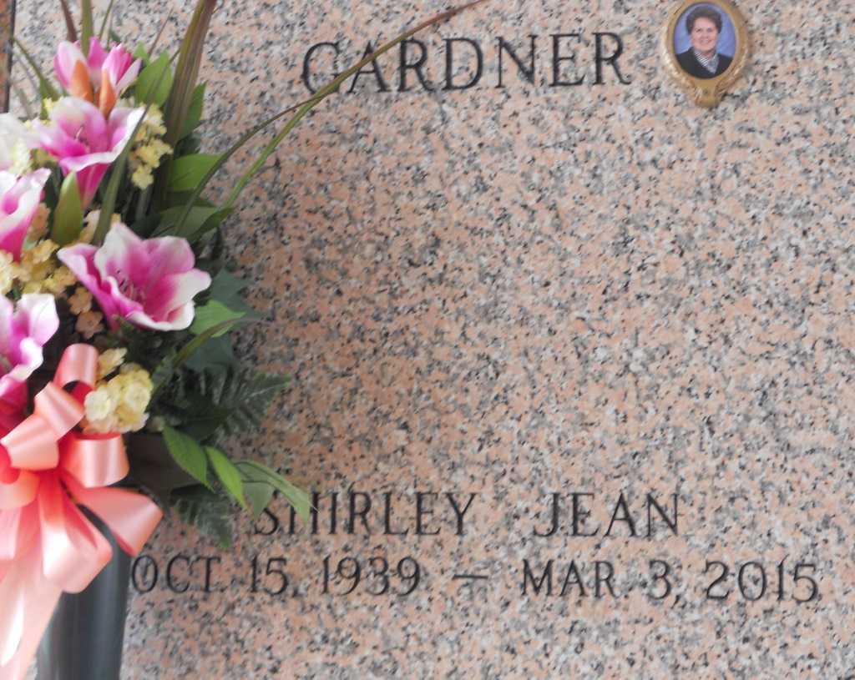

Photo by Team T Lo

Shirley Jean Gardner passed away peacefully at her residence on Tuesday, March 3, 2015, at the age of 75. She was a native of Little Rock, Ark. and a resident of LaPlace.  
 Beloved wife of George Gardner, Jr. Loving mother of Debbie Gardner LaMeer (Daryl), Melissa Gardner (David), David Wayne Gardner (Michele), George Gardner III (Judy), Cathy Bergeron (Robert) and the late Candace Ann Tarver (Paul). Grandmother of Dr. Shirley Visser (Jared), Stanley Catoire Jr. (Lacey), Ashley Huet, Kaylyn and Brennan Gardner, George Gardner IV, Jennifer Gardner, Jason and Jy Sanders, Robert (Tracey), Codi (Jay) and Katie Bergeron and the late Amanda Poche, Jade Sanders. Great grandmother of Lillian Visser and Seth Catoire. Daughter of the late Willie Mae Harrington and W. A. Jones. Sister of Sue Collins, Annie Mae Morris, Patty Cortez and the late Billy and Bobby Jones. Sister-in-law of Shirley Chauvin, Patsy Malone and the late Lydia Herty. Also survived by numerous nieces, nephews and step great grandchildren.  
 Relatives and friends are invited to attend the Funeral Service at First Baptist Church of LaPlace, 120 Ormond Blvd., LaPlace on Friday, March 6, 2015, at 11:00 a.m. Visitation will begin in church at 10:00 a.m. Interment in St. John Memorial Gardens Cemetery.   
 Arrangements by Millet-Guidry Funeral Home.

Unknown source