Annabelle (Vicknair) Gaubert

October 28, 1930 – January 3, 2006

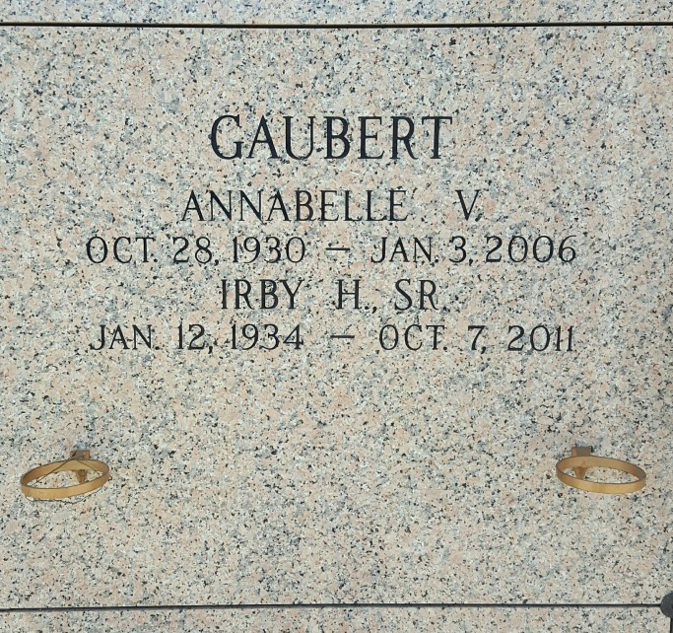

Photo by mbc

LAPLACE - Annabelle Vicknair Gaubert, 75, a native of Edgard and a resident of LaPlace, died Jan. 3. She was the wife of Irby Gaubert Sr.  
  
She is survived by her children Cheryl (Manuel) Delaune, Carolyn (Glenn) Davis, Patricia (Danny) Schexnaydre, Donnie, Irby (Dawn) Jr. and Karen (fiance Eric Cresse) Gaubert.  
  
She is also survived by her siblings Raoul, Wallace, Nelson and Zephyrain Vicknair Jr., Doris Guillot, Jeanette Deocampo and Dora Ann Newsome, grandchildren Scott Rome, Jack Cali, Kevin Delaune, Ashlynn Schexnaydre, Darrin, Derrick, Eddie and Ricky Gaubert and great-grandchildren Lindsey, Mackenzie and Brant Delaune.  
  
She was preceded in death by her parents Zephyrain and Dora Vicknair Sr., stepson Randall Gaubert and siblings Melvin Vicknair, Lillian Keating, Noelle Michel and Earline Larousse.  
  
Services will be held today at 11 a.m. at Ascension of Our Lord Catholic Church, LaPlace, with interment in St. John Memorial Gardens, LaPlace.  
  
Millet-Guidry Funeral Home is in charge of arrangements. Visitation begins at 8 a.m. at the church.

**L'Observateur (La Place, LA) - Monday, January 9, 2006**

**Contributed by Jane Edson**