Irby H. Gaubert, Sr.

January 12, 1934 – October 7, 2011

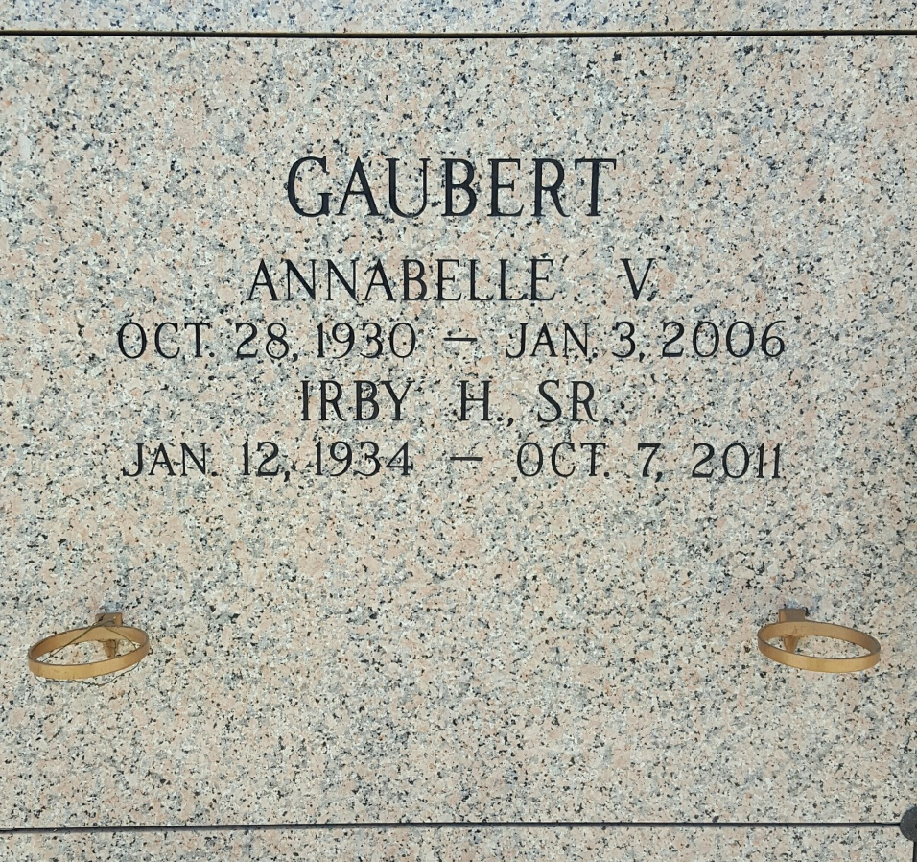

Photo by mbc

Irby H. Gaubert Sr., 77, passed away Oct. 7, 2011.   
 He was the beloved husband of the late Annabelle Vicknair Gaubert and by first  marriage of the late Aline Lorio Gaubert, father of Donnie Gaubert (fiancé Crystal Clement), Irby Gaubert Jr., Karen Gaubert (fiancé Eric Cresse) and the late Randall Gaubert (Dawn); stepfather of Patricia Oubre Schexnayder (Danny) and Carolyn Oubre Davis (Glenn), grandfather of Darren, Derrick, Eddie and Ricky Gaubert; step-grandfather of Ashlynn Schexnayder, Jack Cali III, Scott   
Rome and Kevin Delaune; brother of Leah Cantrelle, and son of the late Ambrose and Leah Gaubert.  
 He was preceded in death by three sisters and five brothers.   
 He was a native of Hahnville and a resident of LaPlace for 47 years.   
He was a retired member of Local Union 60, Pipefitters, Steamfitters and Welders.  
 Services were held at Ascension of Our Lord Catholic Church in LaPlace on Oct.  11, followed by burial in St. John Memorial Gardens Cemetery.   
 Arrangements were by Millet-Guidry Funeral Home.

Unknown source