Russell J. Gaudet Jr.
October 1, 1952 - December 2, 2001

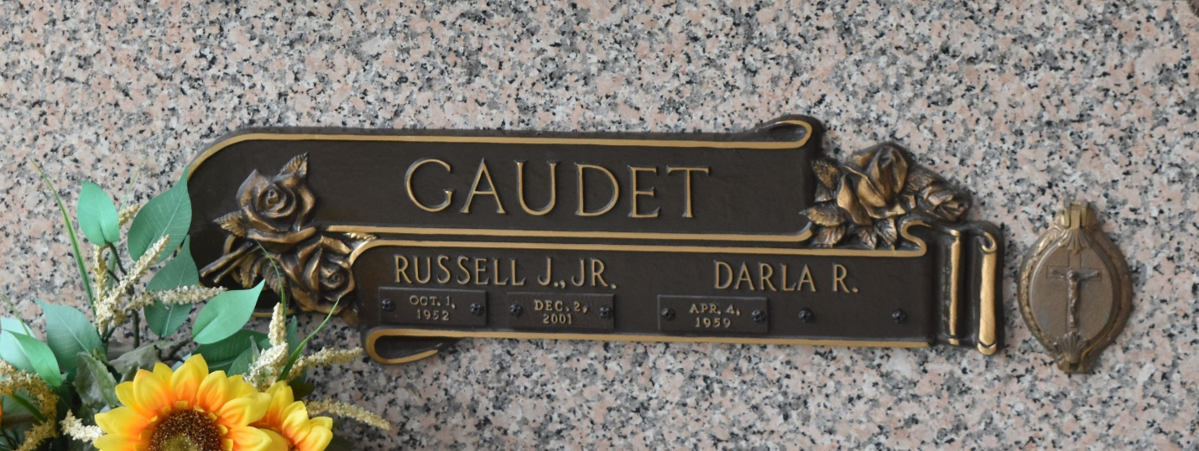

Russell J. Gaudet Jr., 49, a native of Marrero and resident of LaPlace for 13 years, died Dec. 2. He was the husband of Darla Gaudet and father of Jenne, Ashleigh, Rusty and the late Ryan Gaudet. He was the son of Betty Schexnaydre and the late Russell Gaudet Sr. and brother of Joyce Bradberry, Mary Ann Mack, Cindy Schroder and Ricky, Jeff and Keith Kerner. He served in the U.S. Army for four years and was the owner of St. John Enterprise.
Services are today at 10 a.m. at St. Joan of Arc Catholic Church, LaPlace, with interment at St. John Memorial Gardens, LaPlace. Visitation starts at 8 a.m.
L'Observateur, LaPlace, Louisiana
December 1, 2001

