Felix Joseph Gaudet III
December 22, 1939 – August 11, 2009

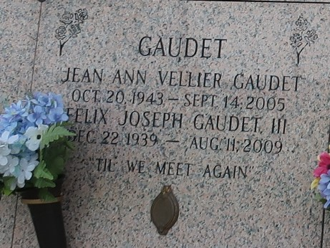

Felix Joseph "Joe" Gaudet III, 69 years old of Independence, LA, died Tuesday, August 11, 2009, at his residence. Joe was born on Friday, December 22, 1939, in New Orleans. He was President of Kenner Equipment, in Kenner. Surviving are 3 sons & daughters-in-law, Felix "Joey" Gaudet IV and Lisa Boudreaux Gaudet, Timothy Allen Gaudet and Angie Zerangue Gaudet, Richard Frank Gaudet and Tiffany Gaudet; brother, Ronald Frank Gaudet; 4 grandchildren, Andrew Allen Gaudet, Alex Samuel Gaudet, Joel Gaudet and Emily Jean Gaudet. He is preceded in death by wife of 41 years, Jean Ann Vellier Gaudet; parents, Felix and Shirley Gaudet Jr.
Friends will be received Thursday, August 13, 2009, at the Harry McKneely & Son Funeral Home in Hammond from 6:00p.m. until 9:00p.m. and on Friday from 8:00a.m. until services. Services will be held in the funeral home chapel, Friday, August 14, 2009, at 10:00a.m., with Rev. Ed Griffen officiating. Interment will follow in the St. John Memorial Gardens, LaPlace, Louisiana 70068. An on-line guest book is available at www.harrymckneely.com.
The Times-Picayune, New Orleans, Louisiana
Aug. 12, 2009

