Jean Ann (Vellier) Gaudet
October 20, 1943 – September 14, 2005

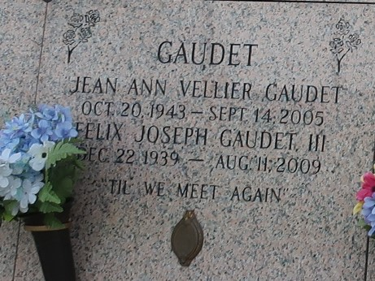

Jean Ann Vellier Gaudet, 61, died Wednesday, Sept. 14, 2005, at her home in Independence. She was born Oct. 20, 1943, in New Orleans, the daughter of the late Russell Anthony and Marie Richard Vellier. Mrs. Gaudet was the secretary/treasurer of Kenner Equipment, Kenner. Surviving are her husband, Felix "Joe" Gaudet III of Independence; three sons and daughters-in-law, Felix "Joey" and Lisa Boudreaux Gaudet IV of Ponchatoula, Thimothy Allen and Angie Zerangue Gaudet of Destrehan, and Richard Frank and Tiffany Gaudet of Independence; three sisters, Iris Patterson of Carthage, Texas, and Kay Miller and Eris Khalil, both of Metairie; brother, David Vellier of Homer; and three grandchildren, Andrew Allen Gaudet, Alex Samuel Gaudet and Joel Gaudet.
She was preceded in death by two sisters, Joan Valeni and Virginia Mahl; and a brother, Russell "Tony" Vellier Jr.
Friends will be received at Harry McKneely & Son Funeral Home, Hammond, from 6 p.m. to 10 p.m. Thursday, Sept. 15, and after 8 a.m. Friday. Funeral service in the chapel at 11:30 a.m. Friday, conducted by the Rev. Ed Griffin. Interment in St. John Memorial Gardens, LaPlace. E-mail condolences to hmckneely@i-55.com, subject line: Gaudet.

The Advocate, Baton Rouge, Louisiana
Sep. 15, 2005

