Kinnel Louis Gauthier, Jr.

February 21, 1936 - July 14, 2020

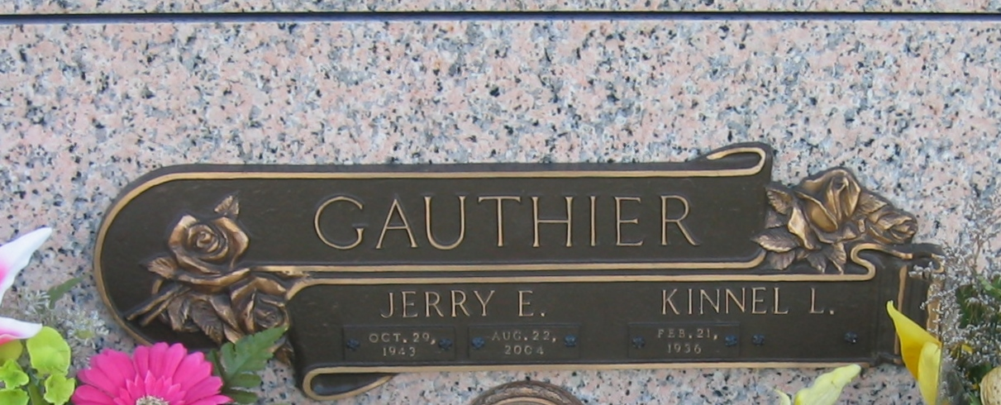

Photo by Bobby

Kinnel Louis Gauthier, Jr. passed away on Tuesday, July 14, 2020 at the age of 84. He was a native of Hamburg, LA and a resident of LaPlace, LA. Beloved husband of the late Jerry E. Gauthier. Loving father of Chantelle Epperly (Dennis) and Chadna Gauthier (Ryan). Grandfather of Tyler Gauthier, Dustin Epperly and Alysa Epperly. Son of the late Kanile Gauthier and Ezilda Lemoine Gauthier. Also survived by his sister, Leila Conway and many nieces and nephews.  
 Relatives and friends are invited to attend the visitation at Millet-Guidry Funeral Home, 2806 W. Airline Hwy., LaPlace on Monday, July 20, 2020 from 9:00 a.m. until 11:00 a.m. followed by a Funeral Service 11:00 a.m. Interment in St. John Memorial Gardens Cemetery, LaPlace. Due to the current circumstances, everyone is required to wear a mask for the protection of themselves and other attendees.

Millet-Guidry Funeral Home, LaPlace, LA

July 16, 2020