Oscar A. Gautreaux

December 20, 1934 – September 28, 2012

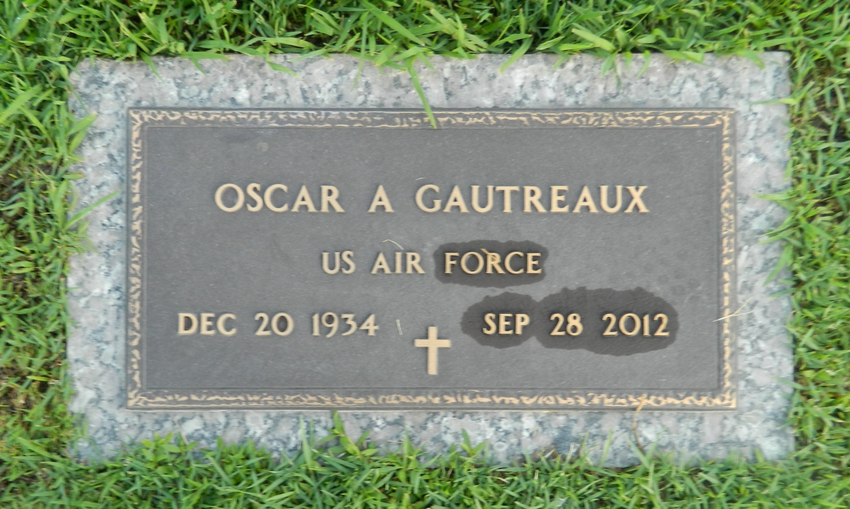

Oscar Gautreaux passed away on Friday September 28, 2012. Beloved son of the late Ellis and Edna Gautreaux. Brother of Allen Gautreaux and Lillian Perez. Friend of Sammie Wakins and L. J. Wempren. Age 77. A native of St. Rose and a resident of LaPlace.  
  
Relatives and friends are invited to attend services. Visitation at Millet-Guidry Funeral Home, 2806 W. Airline Hwy. LaPlace, LA on Monday October 1, 2012 from 9:00 am to 10:00 am, followed by Religious Services in The Funeral Home Chapel at 10:00 am. Burial in St. John Memorial Gardens Cemetery, LaPlace, LA.

Times-Picayune, The (New Orleans, LA) - Sunday, September 30, 2012

Contributed by Jane Edson