Vera Mitchell) Gautreaux

April 11, 1943 – October 13, 2004

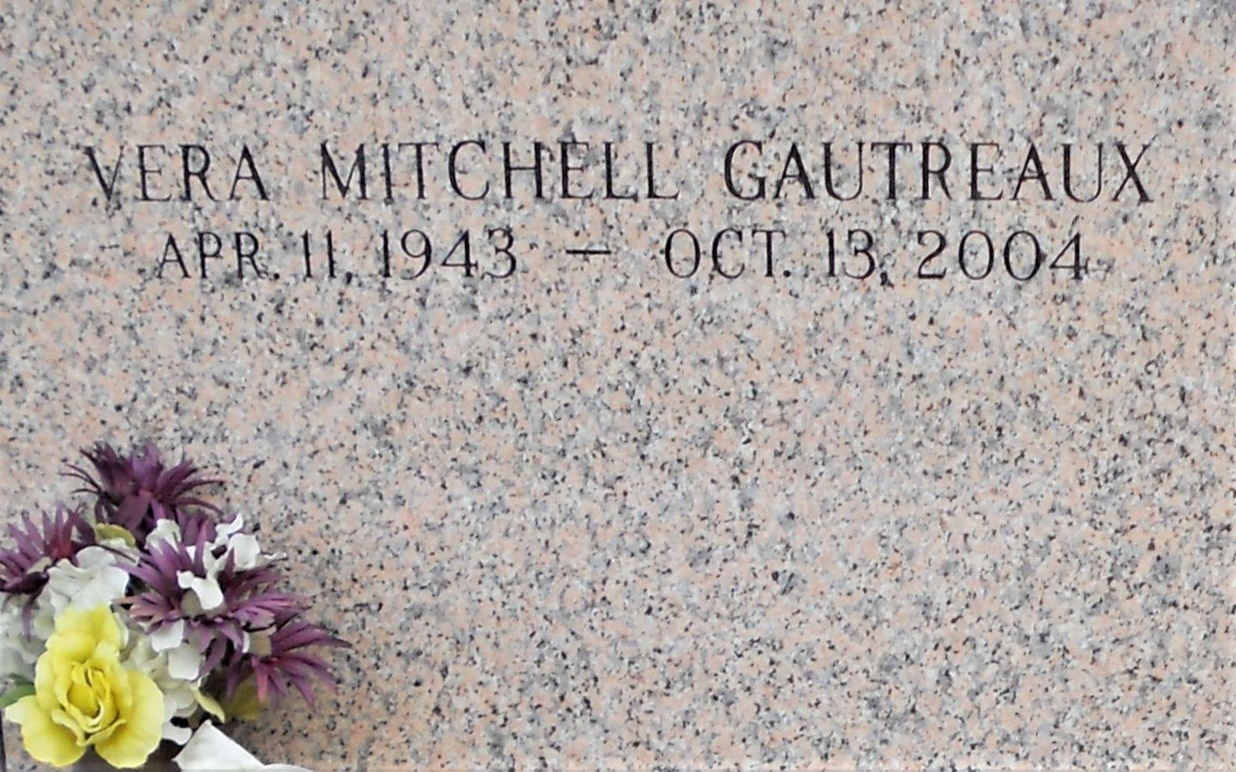

Photo by Team T Lo

Vera Mitchell Gautreaux On Wednesday, October 13, 2004 At 7:00 A.M. Beloved Mother Of Julie Gautreaux, Annette Breaux, Faith Stout, Vera Colon And The Late Joseph Gautreaux. Daughter Of The Late Dewey And Geneva Mitchell. Sister Of Troy And Jerry Mitchell. Also Survived By 10 Grandchildren. Age 61. A Native Of New Orleans And A Resident Of Laplace For The Past Year. Relatives And Friends Of The Family Are Invited To Attend Services. Visitation At Millet-Guidy Funeral Home, 2806 W. Airline Hwy., Laplace On Friday, Octber 15, 2004 From 10:00 A.M. To 12:00 Noon Followed By Religious Services In The Funeral Home Chapel At 12:00 Noon. Burial In St. John Memorial Gardens, Laplace.

Times Picayune (LA); 10-14-2004