Jerry James Gendron
August 6, 1930 – January 18, 2015

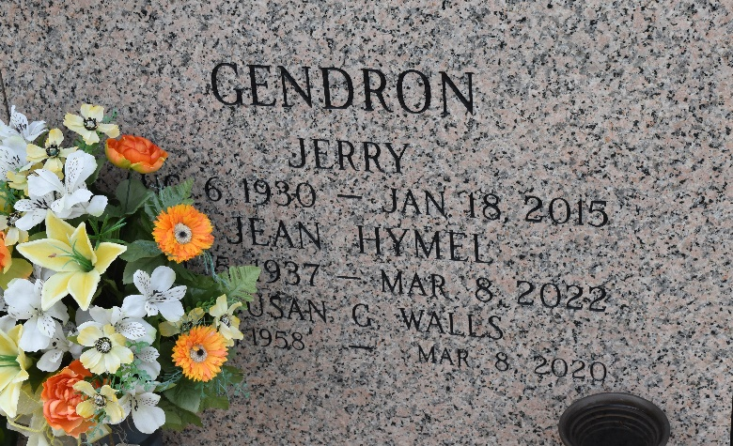

Jerry James Gendron passed away on Sunday, January 18, 2015. He was 84, a native of Lucy, LA and a resident of LaPlace, LA. Beloved husband for 58 years of Jean Hymel Gendron. Father of Susan Bourgeois, Gail Bergeron (Francis), Alan Gendron (Linda), Larry Gendron (Lisa) and Kathy Cambre. Son of the late Marie Lise Landeche Gendron and Jules Gendron. Brother of Sylvia Boudreaux (the late Louis), Virgil Gendron and the late Floyd Gendron (Joyce). Grandfather of Brandon (Nicole) and Kory Gendron, Casey (Jamie) and Derek Cambre, Allison Bergeron Ortega (Alfredo), Lauryn Bergeron Donaldson (Josh), Lance and Lane Gendron and Brittany and Brooke Walls. Great-grandfather of Brinley, Nathan, Lexie, Talan, Peyton, Trey, MacKenzie, Isabella, Anastasia, Alfredo 'Freddy', Saige and Baby Grace. Son-in-law of the late Rowley and Mabel Hymel. Brother-in-law of Rowley 'Sonny' and Jeanette Hymel, Bryan and Marie Etta Hymel, James 'Jimmy' and Janet Hymel and the late Katherine 'Teena' Hymel. Also survived by many nieces and nephews. Jerry retired from Shell Oil Company in 1989. He enjoyed spending time with his family and tending to his cattle. Bowling was a favorite past-time for many years.
Relatives and friends are invited to attend services as follows: Visitation St. Joan of Arc Catholic Church, 529 W. 5th Street, Laplace, LA 70068 on Thursday, January 22, 2015 at 10:00 a.m. Funeral Mass St. Joan of Arc Catholic Church on Thursday, January 22, 2015 at 12:00 noon. Interment in St. John Memorial Gardens Cemetery. To view or sign the online guest book, please visit www.milletguidry.com Millet-Guidry Funeral Home 2806 West Airline Highway LaPlace, LA 70068 (985) 536-7700
The Times-Picayune, New Orleans, Louisiana
Jan. 20 to Jan. 21, 2015

