Liberato Vince Gentile
July 4, 1924 – October 5, 2014

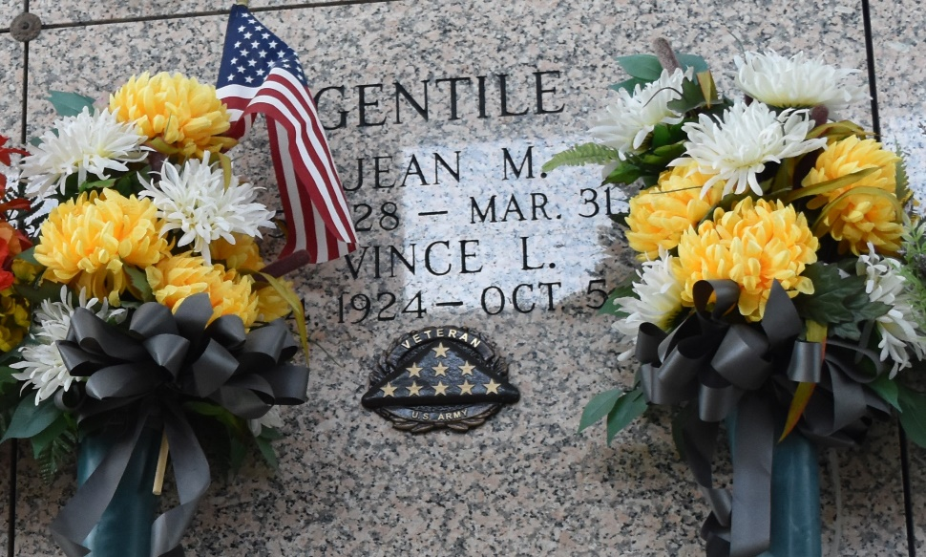

Liberato “Vince” Gentile passed away on Sunday, October 5, 2014 at the age of 90. He was a native of Camden, NJ and a longtime resident of LaPlace. Vince proudly served his country in the U. S. Army during WW II in the 2nd division that landed on Normandy Beach. He was a 4th degree Knight (Archibishop Blank Assembly 318) and also a member of Msgr. Bergeron Council 5935, a member of the VFW Post in LaPlace and a designer of men’s and women’s clothing with Oleg Cassini.
Beloved husband of the late Jean Cassotta Gentile. Loving father of Jeannine Gentile, John Gentile, Louisa Gentile, Jordan Colletta, Anita Colletta and the late Duane Colletta. Son of the late John and Rose Gentile. Brother of Nicholas Gentile (Grace), Maria Wagner (the late, Paul), and the late Giulia Gentile, Theresa Knickerbocker (the late, Jack), Leonora Gebelein (Richard, Sr.), and Patrick Gentile (the late, Clara). He is also survived by 16 grandchildren, 25 great grandchildren and 2 great great grandchildren.
Relatives and friends are invited to attend the Funeral Mass at St. Joan of Arc Catholic Church, 529 W. 5th St., LaPlace on Thursday, October 9, 2014 at 12:00 noon. Visitation will begin in church at 10:00 a.m. Interment in St. John Memorial Gardens Cemetery.

Millet-Guidry Funeral Home, LaPlace, Louisiana

