Gail (Conlee) George
April 21, 1941 – March 13, 2000

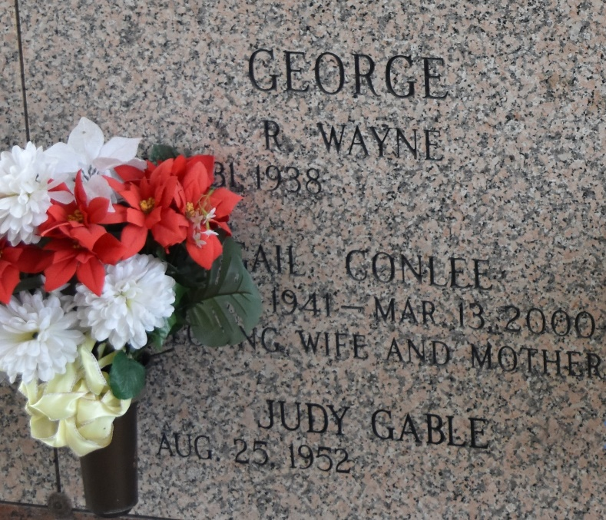

LAPLACE - Gail Conlee George, 58, a native of New Orleans and resident of LaPlace for 28 years, died March 13. She was the wife of Wayne George, mother of Cindy Gillies, Joey Scontrino III, Joy Scontrino and Chandra Fisher and step-mother of Kendra Toney, Cheryl Ricca and Bonnie Hempstad. She was also the daughter of the late Bonalee and Rachel Conlee and sister of Bonalee Conlee. She is also survived by seven grandchildren, nine step-grandchildren and one step-great-grandchild. She was a member of the St. John the Baptist Parish Zoning Board.
Services were held March 16 at First Baptist Church, LaPlace, with interment at St. John Memorial Gardens, LaPlace.
L'Observateur, LaPlace, Louisiana
March 19, 2000

