Saundra Dee (Molton) George

October 28, 1960 – August 16, 2006

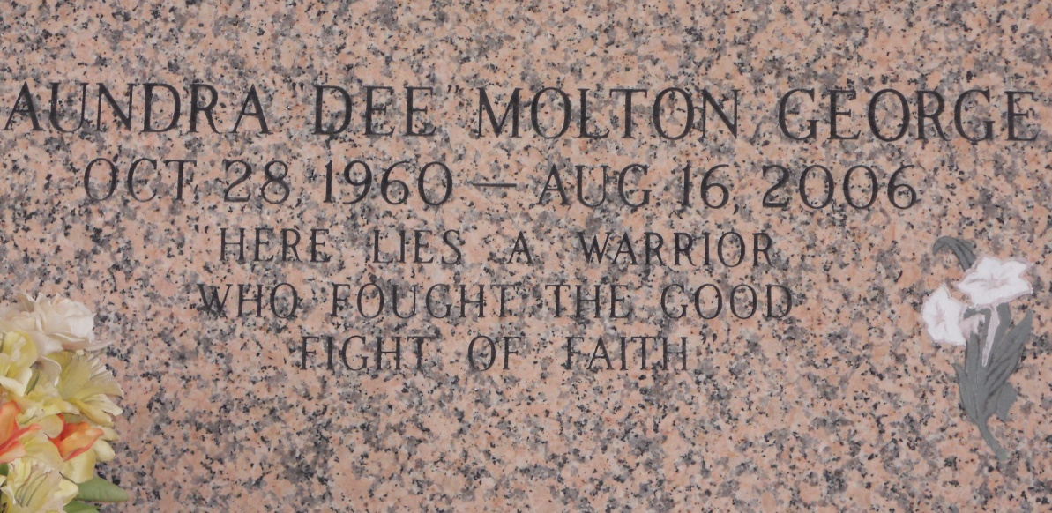

Photo by Team T Lo

Saundra "Dee" Molton George, Age 45 departed this life on Wednesday August 16, 2006 in Kingwood, TX, Daughter of Hilda F. Molton and the late James Molton, Jr., Wife of Thomas "TG" George, Sr., Mother of Taj, Thomasina, Jason, and Thomas George, Jr., and Stepdaughter Natasha Plattenburg, Sister of Melissa Molton, and Timothy Molton, Sr. Also survived by 1 daughter in law, Stephanie George, 2 Grandchildren Corielle Plattenburg and Daisha Renee George, Sisters and brothers in law, nieces, nephew, other relatives and friends.  
  
Pastor, and members of Bethlehem B.C. and all neighboring churches are invited to attend funeral service on Tuesday August 22, 2006 at 10:00a.m. From the above named church, East 20th Street. Reserve, La. Dr. Forell Bering, Sr., Pastor Officiating and Interment in Saint John Memorial Gardens Laplace, La. Visitation on Tuesday at the church from 9:00a.m. Until funeral time.  
  
Service Entrusted to Fall Creek Memorial Chapel & Funeral Home, Humble, TX And Hobson Brown Funeral Home, Garyville, LA

Times-Picayune, The (New Orleans, LA) - Monday, August 21, 2006

Contributed by Jane Edson