Danielle Marie Georgel

August 1, 1992 – December 15, 2016

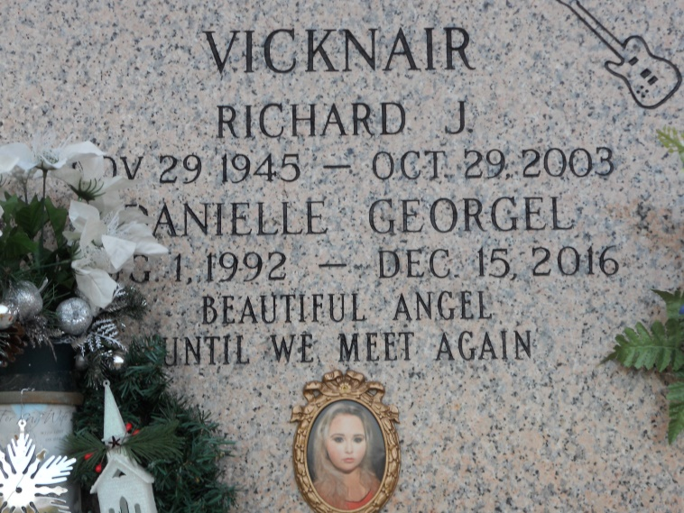

Photo by Team T-Lo

Funding drive underway after 24-year-old killed in crash

LAPLACE — A funding drive is underway to pay for the funeral costs associated with the tragic death of 24-year-old Danielle Marie Georgel, killed Thursday in a two-vehicle crash in Reserve.  
 Father Matthew Johnston of St. Joan of Arc Catholic Church said the church and community members are offering their deepest condolences and promises of prayer for the family and friends of Georgel.  
 "Her death has been a very unexpected and tragic event for the family, one for which they were not prepared for emotionally or financially," Johnston said. "Therefore, Saint Joan of Arc is asking for the parish community to come together and support this family in their time of need."  
 Those interested in helping can donate at gofundme.com/danielle-marie-georgel.  
 Georgel's mother, Angela Vicknair, said there would be a public visitation from 10 a.m. to 12:30 p.m. today (Dec. 21) at Millet-Guidry Funeral Home in LaPlace, followed by a 1:15 p.m. service at St. Joan of Arc Catholic Church.  
 Vicknair said Georgel was an outgoing person, who loved everybody and would do anything to help others. "She was interested in makeup and hair," her mother said. "She did love doing makeup and hair." According to Vicknair, she is going to miss "laughing and joking around about silly stuff" with Georgel the most. Vicknair said Georgel did not have life insurance and "never in a million years thought something like this would happen to her."  
 Georgel was pronounced dead Thursday at Ochsner Health Center – River Parishes following a violent crash.  
 Louisiana State Police Troop B Spokeswoman Melissa Matey said investigators believe Georgel was the front seat passenger in a Ford Taurus driven by 24-year-old Tylas Bailey of Vacherie traveling in the right lane on Airline Highway South approaching Central Avenue. A 2007 Chevrolet Avalanche, driven by 17-year-old Christian Moses of Gonzales, was traveling on Airline Highway North and made a left turn onto Central Avenue. The Ford struck the Chevrolet on the passenger side as the Chevrolet was crossing the southbound lanes of Airline Highway, Matey said.  
 Impairment is not suspected from either driver, but Troopers obtained blood samples from both and toxicology tests are pending. As of this week, Matey said no arrests or citations had been issued but the crash remains under investigation and criminal charges are pending.

L'Observateur (La Place, LA) - Wednesday, December 21, 2016

Contributed by Jane Edson