Gloria D. Givens
December 16, 1952 – December 13, 2020

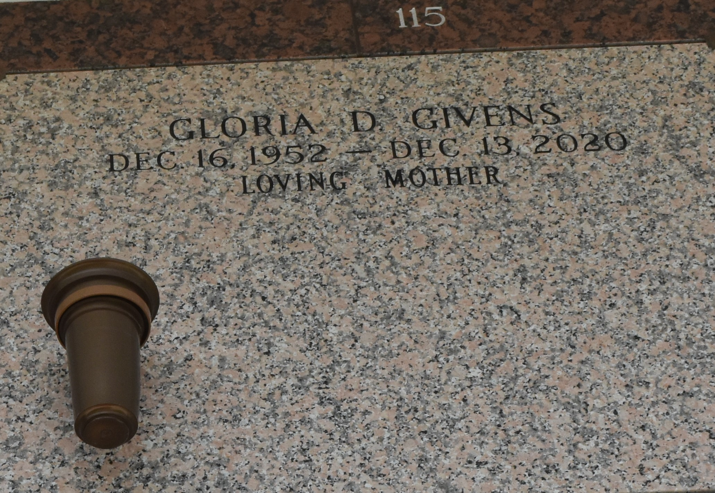

Gloria D. Givens passed away on Sunday, December 13, 2020 at home with her family. She was 67 years old. Beloved mother of Danita Williams, DeShone Jolla, Jermaine, Shonell Williams, Marvin Williams, Antoinette Michael Williams. Sharita. She was preceded in death by her parents Ollie and John Allen Givens, (brother) John A. Givens Jr, (sister) Terecia Givens. Survived by (brother) Andrew Givens, (sister) Bernadine G Steele. Gloria grew up in the lower 9th ward, and attended Alfred Lawless Jr.High school. She loved her job as a ICU secretary at East Jefferson Hospital where she worked for 20 years. Gloria was loved and respected by many. She leaves behind 5 children, 19 grandchildren, and 16 great-grandchildren, and many nieces and nephews.
Please join us in celebrating her life Tuesday December 22, 2020 10:00 am - 12:00 pm for viewing only at Richardson Funeral Home, 11112 Jefferson Hwy, River Ridge. In lieu of flowers, send to Richardson Funeral Home.

The Advocate, Baton Rouge, Louisiana
Dec. 20 to Dec. 22, 2020

