Captain Octavio Rafael Gonzalez

September 2, 1965 – June 16, 2006

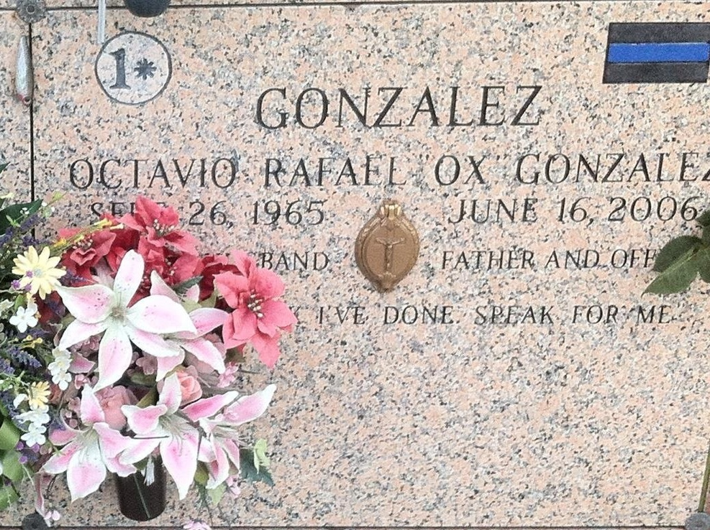

Photo by CirclK

Captain Octavio Gonzalez was ambushed, shot and killed while participating in a manhunt for two suspects who had shot and wounded another deputy minutes earlier, in which a Houston man fired three shots from behind into Capt. Octavio Gonzalez after he was lured from his vehicle by a woman pretending to need help.   
 St. John Parish Sheriff Wayne L. Jones credited Gonzalez with being the architect of the parish's Special Operations Response Team, or SORT, and said his dedication was well-known by SORT and SWAT officers throughout the New Orleans area.   
 Beloved husband of Gloria Breaux Gonzalez. Devoted father of Alexander and Bryson Gonzalez. Son of Cantalicia Gonzalez and the late Mario Gonzalez. Son-in-law of Gloria T. Breaux. Brother of Caridad Artigas, Maria McGlophin and the late Marisol Artigas. Also survived by 4 brothers-in-law, 5 sisters-in-law and 19 nieces and nephews. He was a Police Officer for the Past 17 years.   
 He was a member of Louisiana Tactical Police Officers Association, Louisiana Sheriff's Association, Commander of the Bureau of Narcotics Investigation for the St. John the Baptist Sheriff's Office, Assistant Commander of St. John the Baptist Sheriff's Office Special Operations Response Team. Age 40 years. A native of Havana, Cuba and a resident of Kenner, LA for the past 14 years.   
 Relatives and friends of the family attended the Funeral Mass from St. Catherine of Siena Catholic Church, 105 Bonnabel Blvd., Metairie, LA. on Tuesday, June 20, 2006 at 2:00 PM, followed by interment in St. John Memorial Gardens, LaPlace, LA.   
 He was also a cop's cop, a man so dedicated to his job that his wife, Gloria, often referred to fellow SORT member Capt. Charles "Chuck" Bazile as Gonzalez's "work wife." Among the many adjectives Bazile rattled off to describe his friend was "unique."   
"Unique: There will be only one of its kind, unequal," said Bazile, before Gloria Gonzalez joined him at the podium. "You paid the ultimate cost . . . I lost my friend, my hero. How sad I will be."   
Swat Team Members of departments through out Louisiana attended and wore thier Department Swat Uniform.   
 Reed Pere, who played football with Gonzalez at Nicholls State University, recalled a sociable prankster who sometimes mixed up popular colloquialisms, once referring to someone as the "pot talking to a skillet." "He was a special person," Pere said. "You never felt like a stranger in his presence."

**Undated unknown source**