Ruben O. Gonzalez Sr.
April 2, 1935 – January 12, 2016

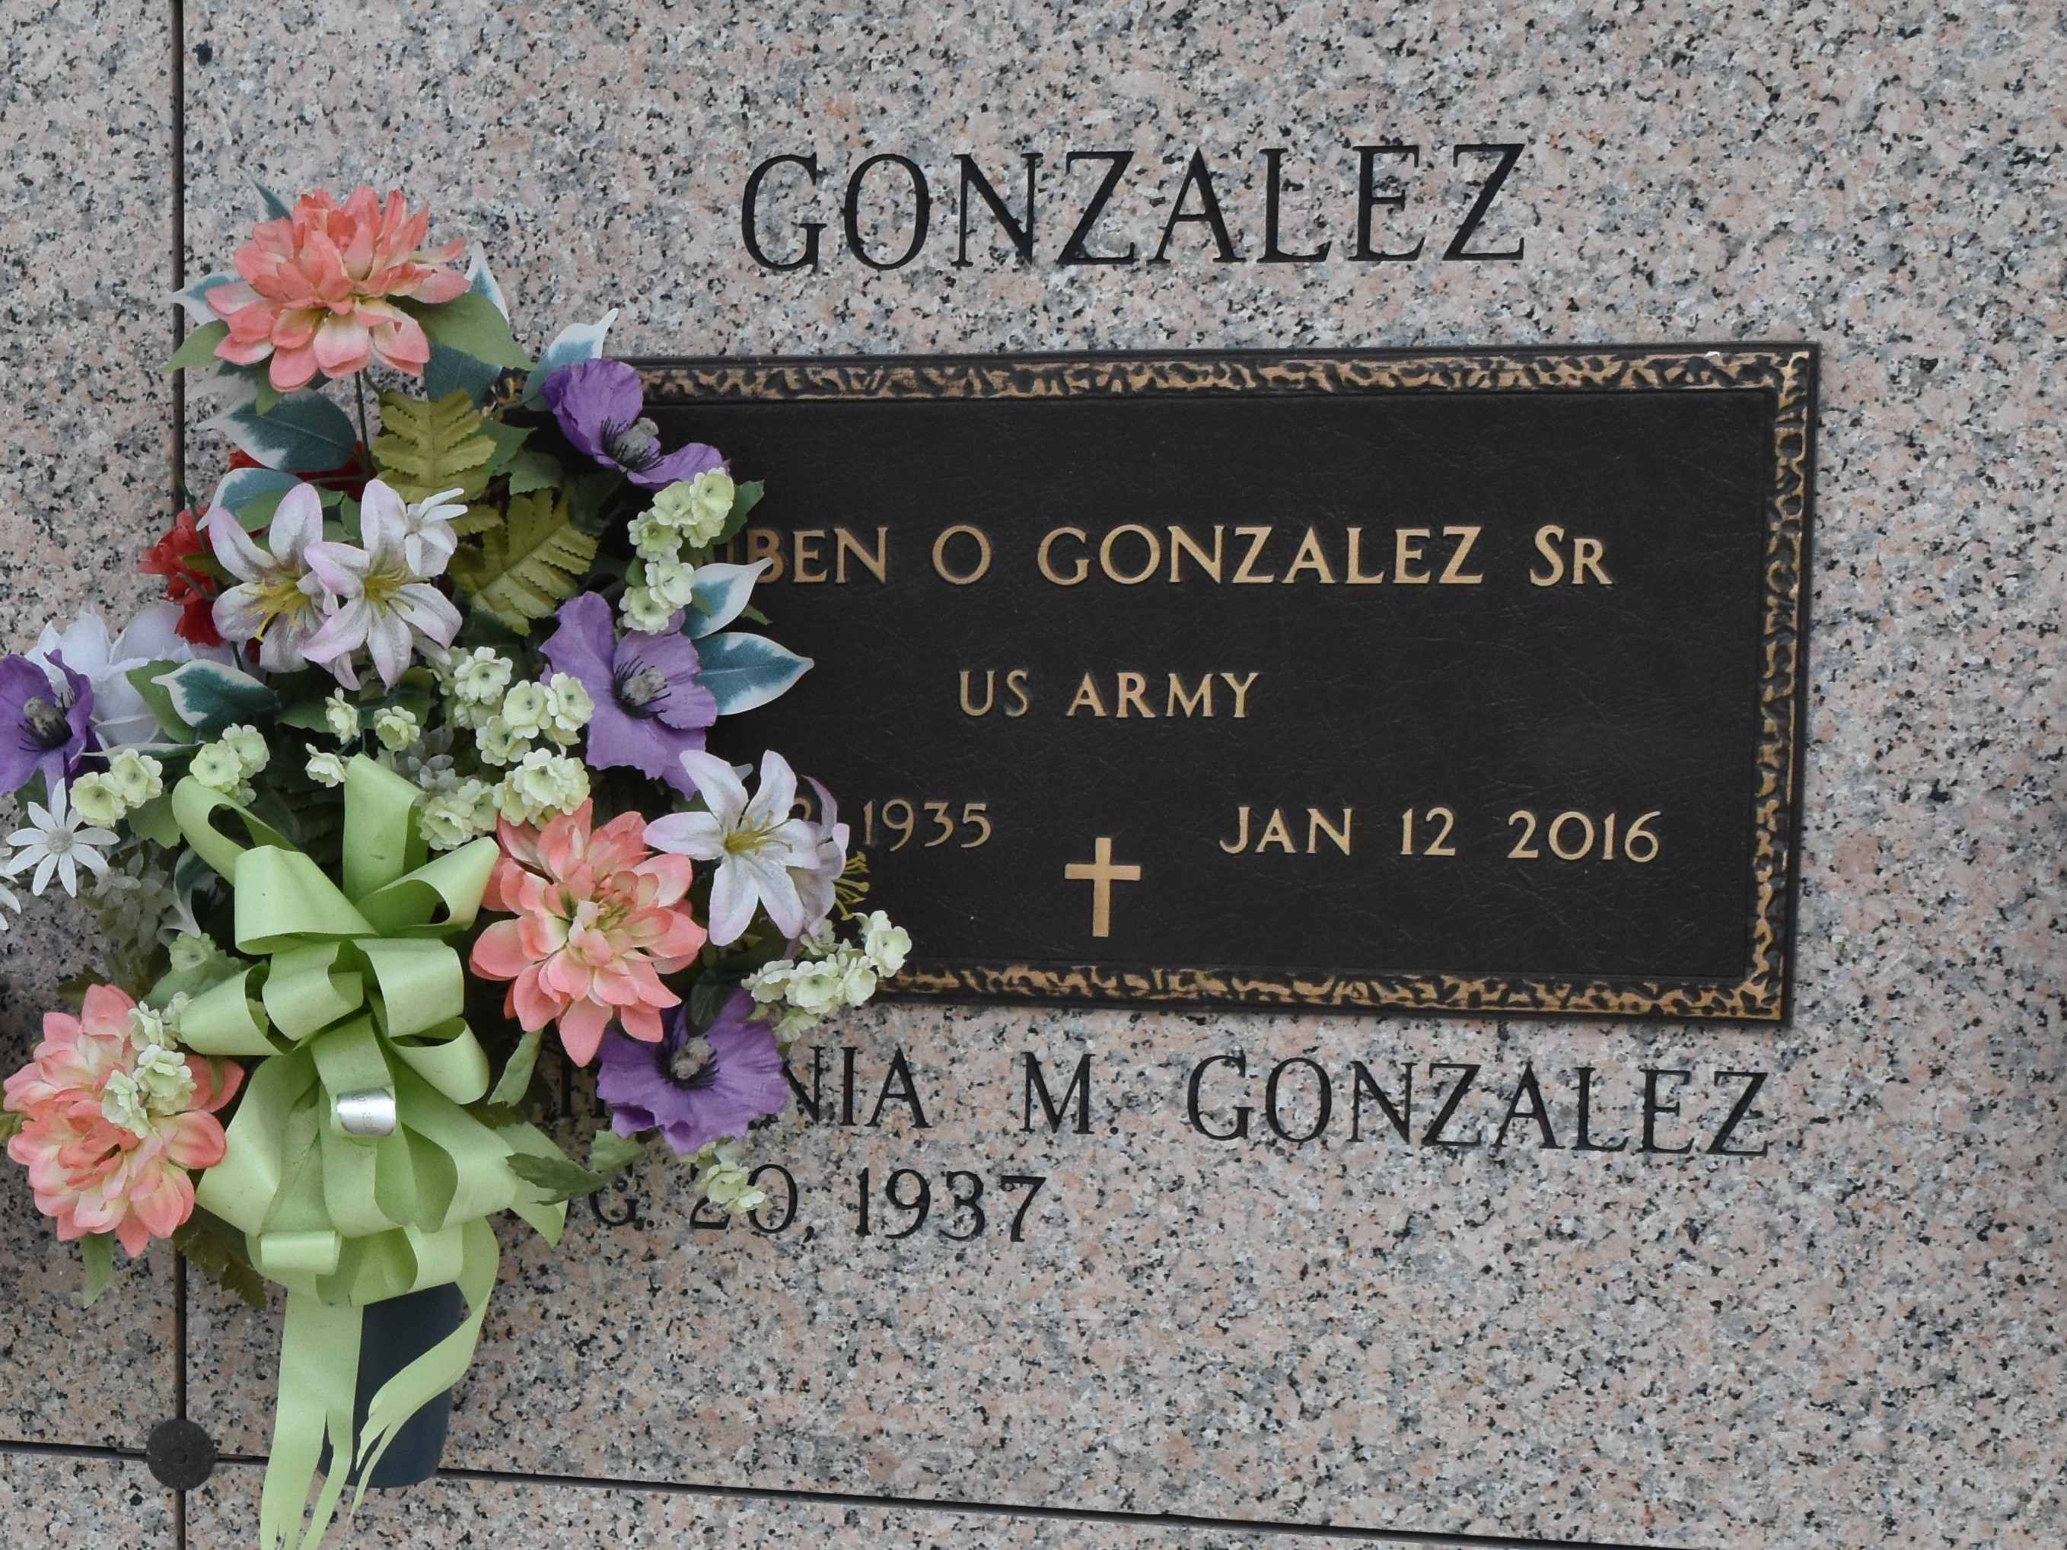

Ruben Gonzalez passed away on Tuesday, January 12, 2016. He was 80, a native of McAllen, TX and a resident of LaPlace, LA. Beloved husband of Virginia Mendoza Gonzalez. Father of Rodney Gonzalez (Joycelyn), Sylvia Foster (Edward) and Ruben Rodman Gonzalez (Joanne). Son of the late Dionicia and Rey Gonzalez. Also survived by 7 grandchildren and 1 great-grandchild.
Relatives and friends are invited to attend the Funeral Service at Millet-Guidry Funeral Home, 2806 W. Airline Hwy, LaPlace on Friday, January 15, 2016 at 10:00 a.m. Visitation on Thursday from 6:00 p.m. until 9:00 p.m. and on Friday from 9:00 a.m. until 10:00 a.m. Interment in St. John Memorial Gardens Cemetery.
Unknown source

