William R. Gooding

1933 – June 9, 2009

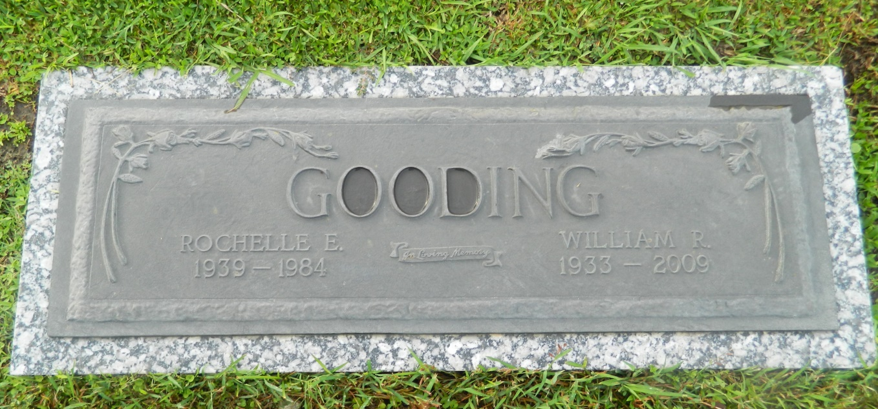

William R. (Bill) Gooding on Tuesday, June 9, 2009 at 12:06 PM. Beloved husband of the late Rochelle Gooding. Father of Bill and Robert Gooding. Grandfather of Abbey and Vaughn Gooding. Age 75 years. A native of Indiana and a resident of LaPlace.  
  
Relatives and friends are invited to attend services. Visitation at Millet-Guidry Funeral Home, 2806 W. Airline Hwy. LaPlace, La on Thursday, June 11, 2009 from 5:00PM to 9:00PM and on Friday from 8:30AM to 10:00AM. Followed by Religious Services in the Funeral Home Chapel at 10:00AM. Burial in St. John Memorial Gardens, LaPlace, La.

Times-Picayune, The (New Orleans, LA) - Thursday, June 11, 2009

Contributed by Jane Edson