Charles Gordon
1937 – November 30, 2014

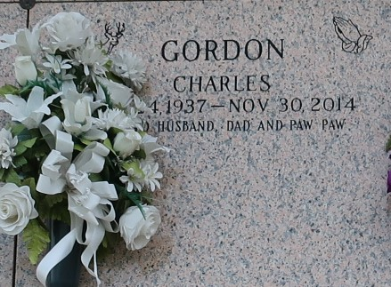

Charles Gordon, age 77, departed this earthly life on Sunday, November 30, 2014 at Ochsner Medical Center in Kenner, La. Mr. Gordon was a native of Luling, La and a resident of Reserve, La. He was married to Olivia Dickerson Gordon for 36 years. Father of Leroy Sr. and Stanley Preston Sr., Rhonda Clement Thompson (Versell Sr.) and the late Kerrick Gordon. Grandfather of Calline, Andre, Cassie and Stanley Jr. and Leroy Preston Jr., Kendrick Hilton, Reonda Clement and Versell Thompson Jr. Brother of Amelia Gordon and Francis Gordon, Willie Mae Gordon Taylor, Eva Gordon Adams (Nathaniel), and the late Matilda Gordon Singleton, Brenda Gordon Fuller (Larry), Lawrence, Alvin Sr., Earl and Romalis Gordon Jr. Son of the late Alice and Romalis Sr. Also survived by a host of nieces, nephews, and friends. He was an avid outdoors man and he will be greatly missed by all.
Family and friends, pastor, officers and members of From My Heart to Yours FWC and Destiny Christian, and employees of Boh Bros Construction and Valero Refinery are invited to attend the Celebration of Life on Saturday, December 6, 2014 at 10:00 am at From My Heart to Yours FWC located at 119 West Fifth St., LaPlace, La. Visitation will begin at 8:00 am until service time. Rev. Carla C. Ceasar is officiant. Interment in St. John Memorial of LaPlace, La. Bardell's Mortuary of Mt. Airy, La. in charge. Information: 985-535-6837.

The Times-Picayune, New Orleans, Louisiana
Dec. 4 to Dec. 5, 2014

