Charles C. Gordon, Jr.  
March 4, 1925 - March 1, 2017

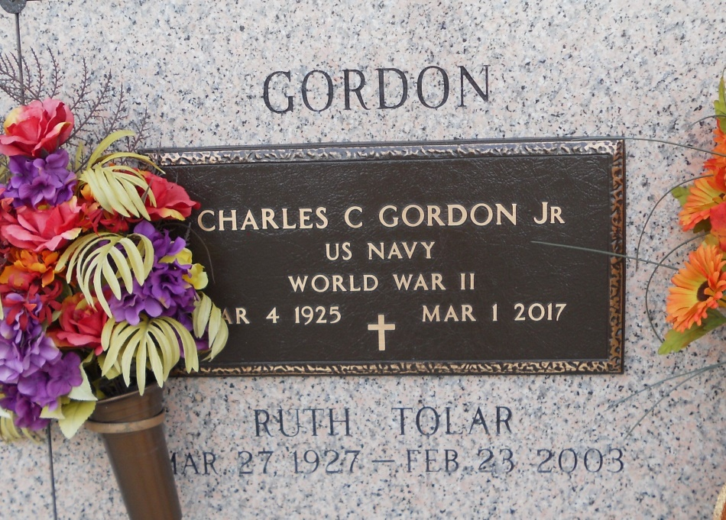  
Photo by Team T Lo

Charles C. Gordon, Jr. passed away on Wednesday, March 1, 2017 in LaPlace, LA at the age of 91. A native of Tallahassee, FL. He was a resident of LaPlace for more the 50 years. Charles was a U.S. Navy Veteran serving during WW II and retired from Gulf Oil Corporation.   
 Son of the late Charles C. Gordon, Sr. and Laurie Munn Gordon. Beloved husband of the late Ruth Tolar Gordon. Father of Lynne Gordon and Kay Gordon Francisco (Joseph). Grandfather of Amanda Bailey Roccaforte (Jeffery), Joseph Francisco, Jr. and Paige Francisco. Great Grandfather of Janie Roccaforte.  
 Relatives and friends are invited to attend the Funeral Service at Millet-Guidry Funeral Home, 2806 W. Airline Hwy, LaPlace on Saturday, January 4, 2017. Visitation from 12:30 p.m. to 2:00 p.m. A Funeral Service will be held at 2:00 p.m. followed by interment in St. John Memorial Gardens Cemetery.

Unknown source