Ronald Wayne Gordon Sr.
December 27, 1953 – November 2, 2017

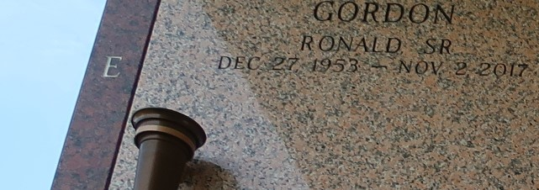

Ronald Wayne Gordon Sr. also known as "Bushmann" departed this life on Thursday, November 2, 2017 at his residence, in Reserve, La. He was the son of the late Wydell and Ella Mae Daniels. Born on December 27,1953, he was a native of Palmetto, La., near Opelousas, La. and a resident of Reserve, La. until his passing at the age of 63. He is survived by: his wife of 44 years, Delores Gordon; six children, Rontego, Rhonda, and Ronald Gordon, Jr. Felicia & Reginald Wiggins, and Rickey Bolden; eight siblings, Joseph (Vanessa) Gordon, twin sister Mary Lee (Michael)Isaac, Janice Gordon, Whylene Duruisseau, Whydell (Rachel) Daniel, Angela (Revan) Duruisseau, Cassandra (Carl) Edwards and Evelyn (Donald) Green; and an uncle Terry (Mary) Stoot; six grandchildren, one great-grandchild, and host of nieces and nephews.
All relatives, friends, members of Ochsner Hospital, Jefferson Hwy. (Main Campus), and surrounding churches, are invited to attend the Mass of Resurrection on Saturday, November 11, 2017, at Our Lady of Grace Roman Catholic Church, 780 Hwy. 44 in Reserve, La. Visitation begins at 8:00 am, Mass begins at 10:00 am, the Rev. Christopher Amadi, SSJ, Pastor. Bardell's Mortuary of Mt. Airy, La. in charge of arrangements. Interment in St. John Memorial Garden in LaPlace, La. May his soul forever rest in peace.

The New Orleans Advocate, Louisiana
Nov. 9 to Nov. 11, 2017

