Ruth (Tolar) Gordon  
March 27, 1927 – February 23, 2003

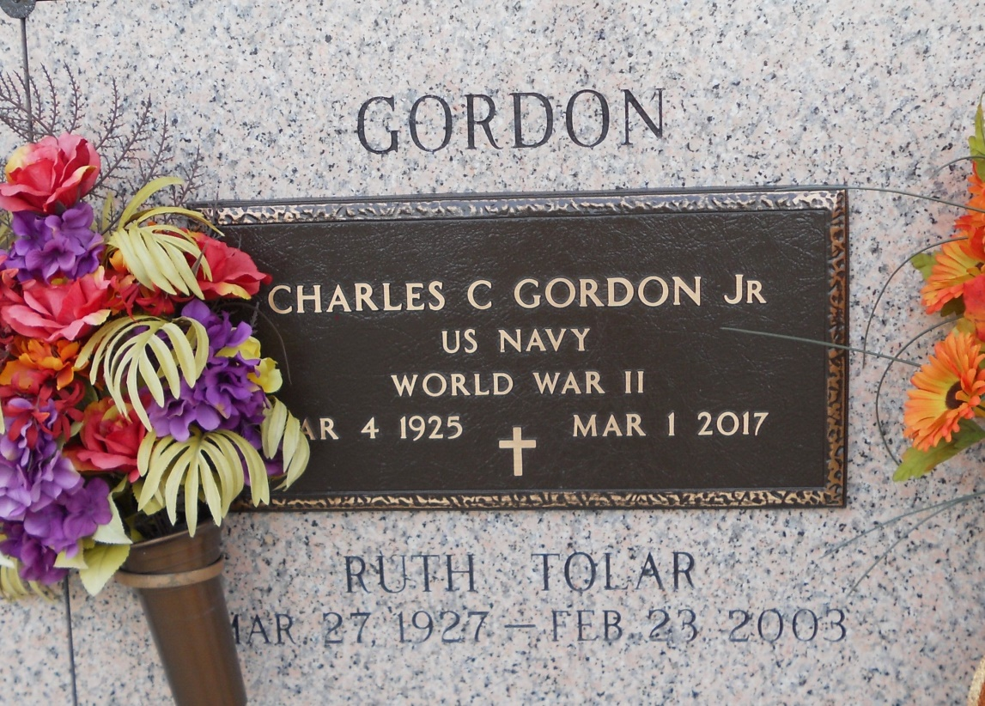  
Photo by Team T Lo

Ruth T. Gordon, On Sunday, February 23, 2003 At 3 Pm. Beloved Wife Of Charles Gordon, Jr. Mother Of Lynne Gordon And Kay G. Francisco. Grandmother Of Amanda Bailey, Joseph Francisco, Jr. And Paige Francisco. Sister Of Margie Miller. Age 75, A Native Of Mississippi And A Resident Of Laplace For The Past 36 Years. Relatives And Friends Of The Family Are Invited To Attend Services. Visitation At Millet-Guidry Funeral Home, 2806 W. Airline Hwy., Laplace, On Tuesday, February 25, 2003 From 5 Pm Until 8 Pm, And On Wednesday From 9 Am Until 10 Am, Followed By Religious Services In The Funeral Home Chapel At 10 Am. Burial In St. John Memorial Garden Cemetery, Laplace.

Times Picayune (LA); 02-25-2003