Robert E. Lee Gorman

April 6, 1929 – July 30, 2004

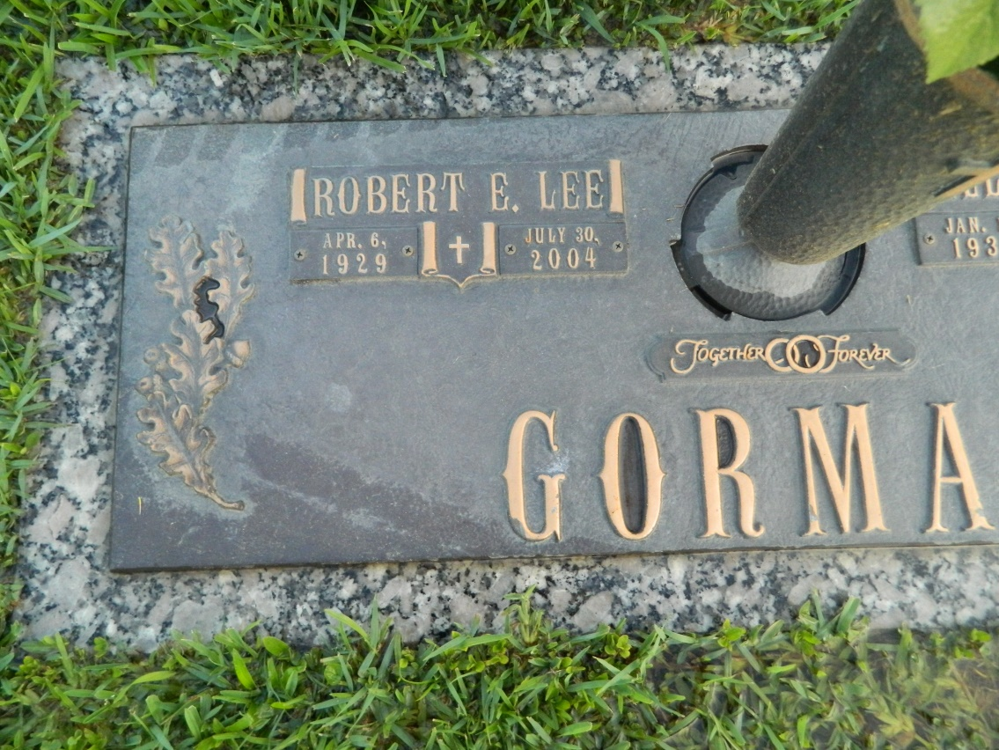

Robert E. Lee Gorman, a retired mechanic, died Friday at Ochsner Foundation Hospital. He was 75. Mr. Gorman was born in Eudora, Ark., and lived in Destrehan for the past 37 years. Survivors include his wife, Ella Mae Gorman; two sons, Bobby and Walter Gorman; a brother; two sisters; seven grandchildren; and two great-grandchildren. A funeral will be held Monday at 11 a.m. at Alexander Funeral Home, 821 4th St., Norco. Visitation will be at 9 a.m. Burial will be in St. John Memorial Gardens.

Times-Picayune, The (New Orleans, LA) - Sunday, August 1, 2004

Contributed by Jane Edson