Theresa (Falcon) Grajkowski
July 20, 1962 - June 25, 2021

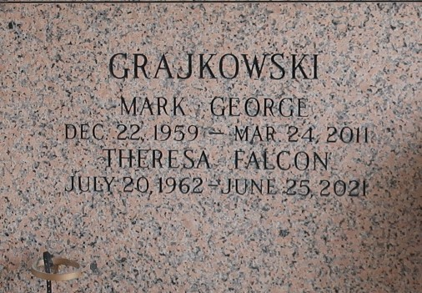

Theresa Falcon Grajkowski passed away on Friday, June 25, 2021 at the age of 58. She was born in White Castle, LA and was a resident of LaPlace, LA. Beloved wife of the late Mark Grajkowski. Mother of Charity Loupe (Shawn Sr.), Monique Eskind (Michael) and Markie Guidry (Cody). Grandmother of Quinn, Shawn Jr., Sophia, Mark and Frankie. Daughter of Vivian Falcon and the late Quinn Falcon. Sister of Wanda Cambre, Todd Falcon, Wendy Andry, Linda Andry and Lesley Noyes. Also survived by many nieces and nephews.
Relatives and friends are invited to attend the Visitation and Funeral Service at Millet-Guidry Funeral Home, 2806 W. Airline Hwy., LaPlace on Wednesday, June 30, 2021. Visitation will be held from 9:00 a.m. until 11:00 a.m. with the Funeral Service to immediately follow at 11:00 a.m. Interment in St. John Memorial Gardens Cemetery.

Millet-Guidry Funeral Home, LaPlace, Louisiana
June 29, 2021

