Hilton P. Green
December 1, 1942 – March 14, 2016

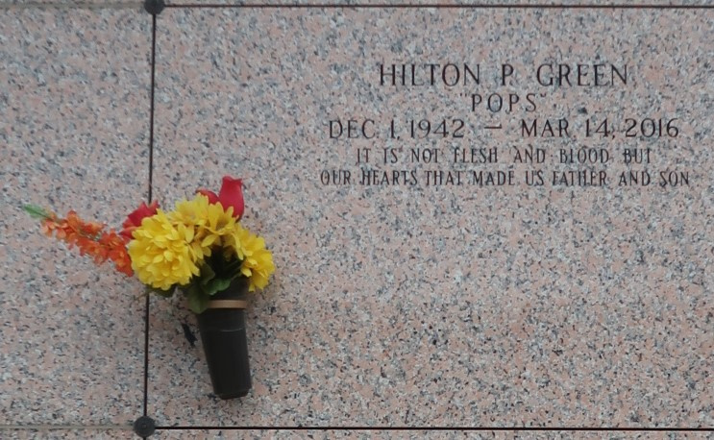

Hilton P. Green departed this life on March 14, 2016 at the age of 73. He is survived by his wife Lorraine Horton; his sons Shawn T. (Candice) Horton , Hilton (Teresa) Green Jr., Damon (Ebony) Horton and Dwayne Horton. Mr. Green is also survived by 9 Grandchildren Dwayne Jones, Jonathan Horton, Logan Horton, Mia Knight, Ellian Green, Green, Tristan Green, Marquel Flowers, Tralacia Green and Kennedy Horton; Godchildren Brandon Watts, Dominique Howard and Penny Thomas. His siblings Cyril (Gwen) Green, Reginald (Patricia) Green, Bobby (Vanessa) Green, Peggy (Charles) Conrad and Earline Wilson.
Relatives and friends of the family are invited to attend Funeral services held at Rise Star Baptist Church on Saturday March 26, 2016 at 11:00 am. 620 Cardinal Dr., LaPlace, LA. 70068. Visitation will be from 10:00-11:00 a.m. the 26th. Interment at St. John Memorial Garden in LaPlace, LA.
The Times-Picayune, New Orleans, Louisiana
Mar. 23 to Mar. 25, 2016

