Lillie Mae Green
August 1935 – June 21, 2020

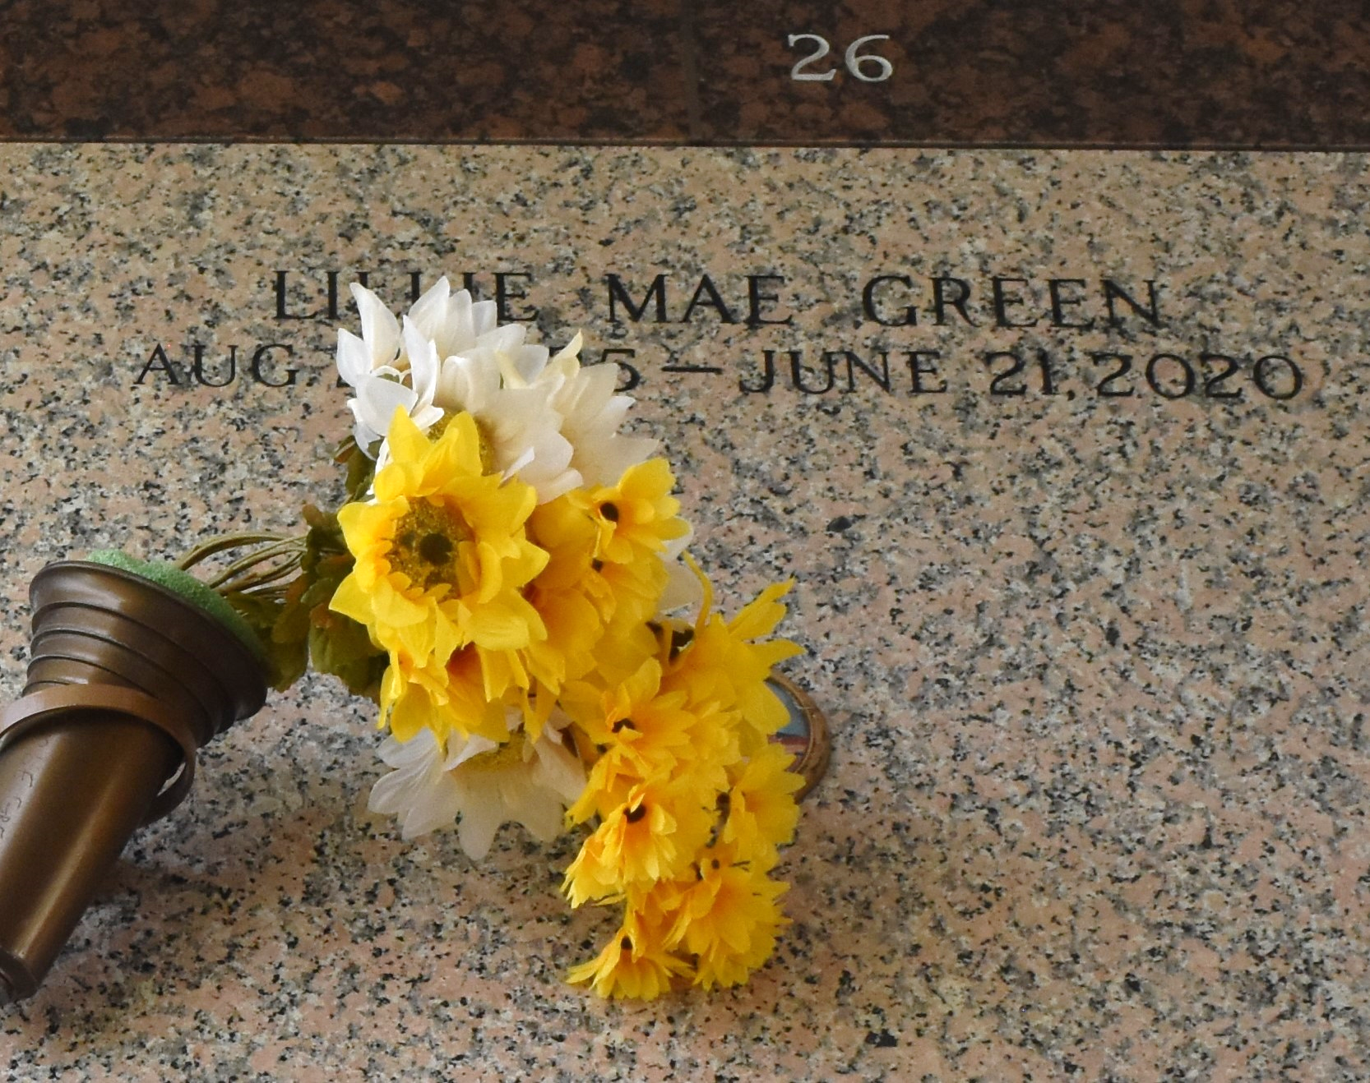

Lillie Mae Green, entered into eternal rest on June 21, 2020, at the age of 84 years old. She was born in New Orleans, LA and a longtime resident of LaPlace, LA. She was the wife of the late Lawrence Green Sr.
She is survived by her daughters, Wanda Jean Roberson, Pamela (Bruce) Perrilloux, Jacqueline Green Fobb, Belinda Ann Green, Wynoka Green Favorite, and the late Sharon "Rat" Miller; sons, Damon (Carol) Roberson and Lawrence Green Jr.; siblings, Lola (Earnest) Turner, Earl (Trina) Johnson, Whilemena Walker, Margaret Johnson, April Johnson, Joseph (Malvena) Keller, Walter Edward, Cheryl (Early) Henry, Janet Kneeland, and Secel Edward; and a host of grandchildren, great-grandchildren, nieces, nephews, other relatives, and friends.
She was the daughter of the late Rozetta (Lola) Johnson and Walter Keller, Sr. Lillie Mae Green served as a cook in St. John the Baptist Parish for many years.
Special thanks to our Park Place Family, Heart of Hospice, and East Jefferson Hospital for their care and generosity of love.
A private family memorial service will be held on Saturday, June 27, 2020 at 11:00 a.m. at Bardell's Mortuary, 3856 LA-44, Mt. Airy, LA 70076. Pastor Devin Mason officiating. Interment at St. John Memorial of LaPlace, LA. Visitation will be at Bardell's Mortuary on Friday, June 26, 2020 from 3 p.m.-5 p.m. and Saturday, June 27, 2020 from 9:00 a.m.- 10:45 a.m.
The Times-Picayune, New Orleans, Louisiana
Jun. 24 to Jun. 25, 2020

