Michael D. Green

November 10, 1993 – May 3, 2016

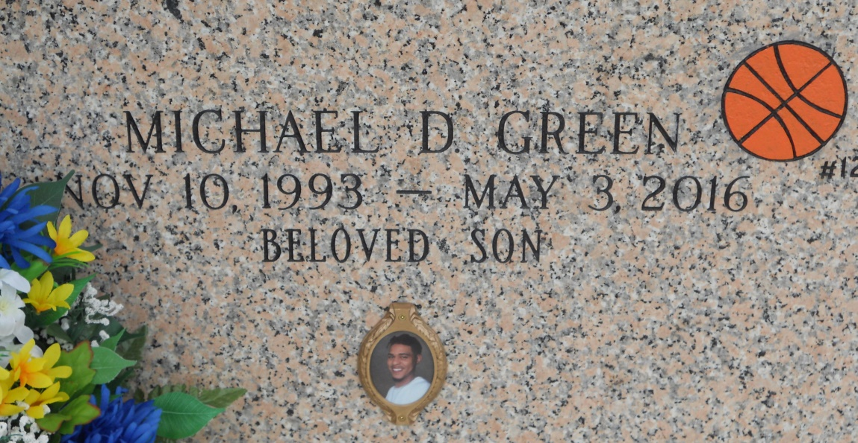

Photo by Team T Lo

A resident of Baton Rouge, He departed this life on Saturday, May 3, 2014 at Baton Rouge General Mid-City, He was 24; visiting at Hambricks Family Mortuary on Friday, May 9, 2014 from 5pm-8pm and on Saturday, May 10, 2014 from 9am until Religious Service time 11AM at St. Paul Baptist Church, Gonzales, Conducted by Rev. Randy Smith. Interment in Cornerview Cemetery. He was a graduate of Dutchtown High School class of 2009. He was very excited and happy after being hired at Blue Runner Corporation. He was a faithful employee up unto his death. Mike leaves to cherish his precious memories: his devoted and faithful parents Trina M. Gaines (Leo) Prairieville, La. and Michael D. Green of Baton Rouge, La. Children: Tailyn Antoine, Samya Finister, Mykah Green, Jordin Green, and a step-son Terrell Addison, Jr. and Michael D. Green, III due this month by his devoted friend, Tameka Scott. Brothers: Fred Grisby and Denzel Green. Sisters: Jazmer Johnson, Precious Johnson, and Shanika Taylor all of Baton Rouge, La. Grandparents: Salone and Helen Green of Baton Rouge, La., Ruby Williams (Cornelius) of Prairieville, La., and Albertha J. Williams (Oscar) of Sunshine, La.. Aunts: Cassandra M. Morris of Covington, La., Belinda Joseph (Bobby), Leslie Morris, Telida Jackson (Danny, Sr.) all of Baton Rouge, La. Uncles: Timothy Green (Lorie), Walter Green (Nicole), and Salone Green, Jr. all of Baton Rouge, La. God-Parents Walter Green and Katina Nelson both of Baton Rouge, La. A brotherly cousin/best friend Danny Jackson, Jr. and a host of other Aunts, Uncles, nieces, nephews, relatives and friends. Hambricks Family Mortuary Inc, Gonzales, in charge of arrangements. [www.hambrickmortuary.com](http://www.hambrickmortuary.com/)

**Advocate, The (Baton Rouge, LA) - Thursday, May 8, 2014**

**Contributed by Jane Edson**