Jaris Vanshawn Griffin
July 27, 1983 – April 23, 2018

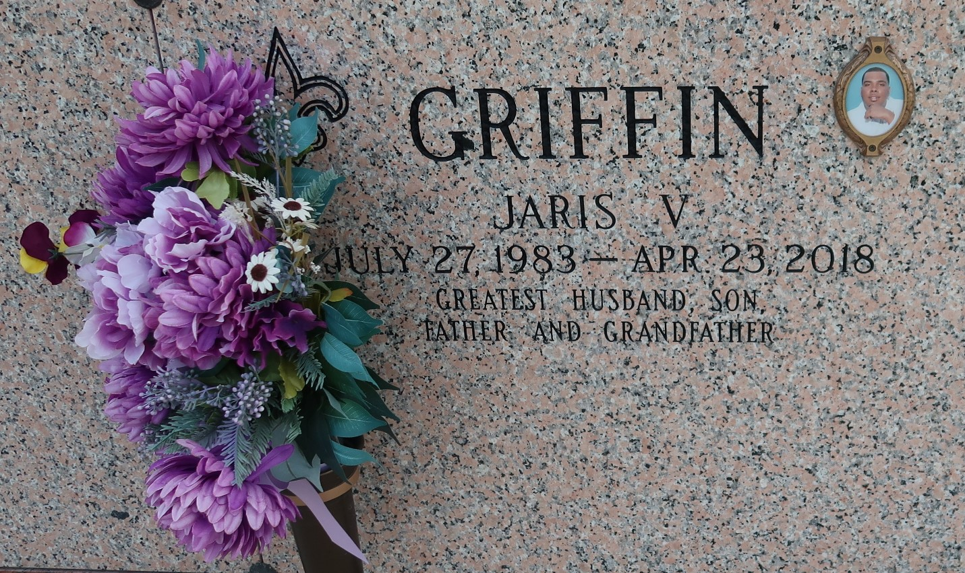

Jaris Vanshawn Griffin "Duke" on Monday, April 23, 2018 at his home in New Sarpy, LA. Son of Graylin August and Caprina Griffin. Loving Husband of Laticia Lewis Griffin. Stepfather of Rayion Lewis and Sean Mosley. Step grandfather of Noiyar Dody. Also survived by a host of aunts, uncles, nieces, nephews, cousins, other relatives and friends. Age 34 years. A native of LaPlace, LA and a resident of New Sarpy, LA.
Relatives and friends of the family, also pastors, officers and members of King David Baptist Church, Fresh Faith Worship Center and all neighboring churches are invited to attend the Funeral Service at King David Baptist Church, 2329 N King Avenue, Lutcher, LA on Saturday, May 5, 2018 at 11:00 AM. Rev. Ferdinand Wallace, Jr., Pastor Rev. Otis Kenner, Pastor of Fresh Faith Worship Center, Officiating. Interment St John Memorial Garden Cemetery, LaPlace, LA. Visitation at the above named church from 9:00 AM until Service Time. SERVICED BY ROBOTTOM
The Times-Picayune, New Orleans, Louisiana
Apr. 27 to May 4, 2018

