Mervin Joseph Guillot, Sr.
December 13, 1935 - March 7, 2019

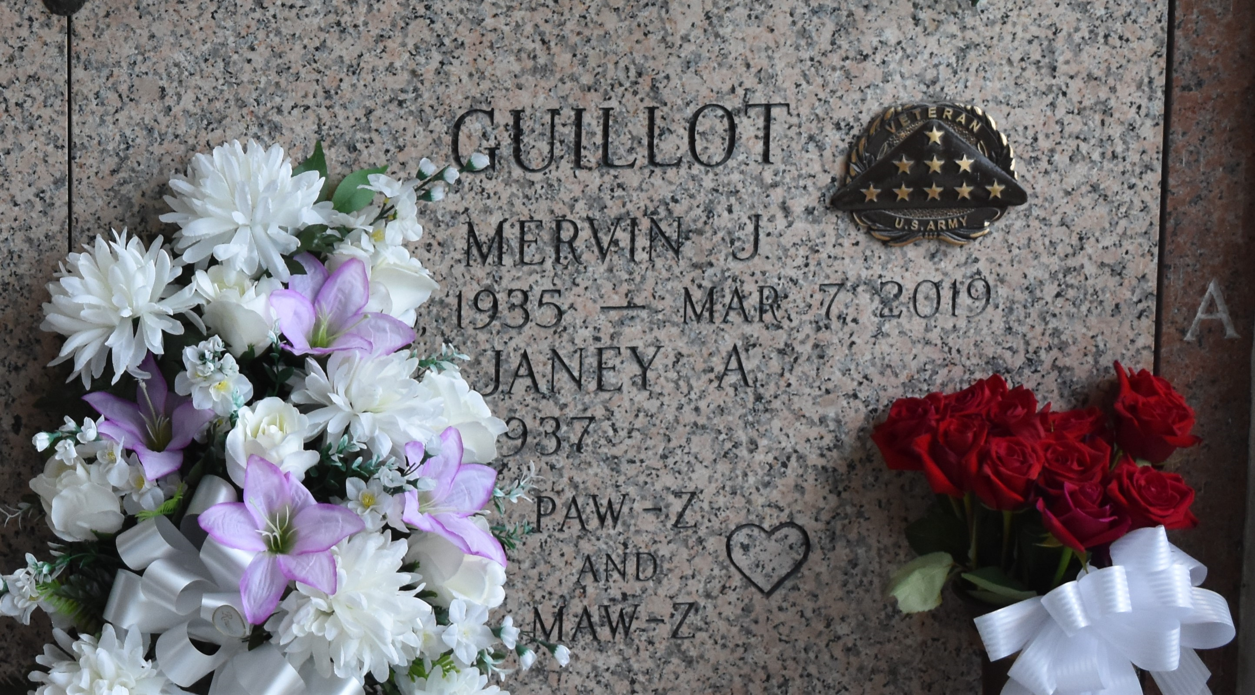

Mervin Joseph Guillot, Sr. passed away on March 7, 2019 at the age of 83. He was a native and resident of LaPlace, LA. He was employed with Shell Norco Chemical Complex for 37 years. He was a veteran of the Korean War.
He is survived by his wife of 61 years, Janey Accardo Guillot; children, Mervin Joseph Guillot, Jr. (Robin) and Cindy Weber (Chris); grandchildren, Michelle Guillot Richard, Ryan Guillot (Jessica), and Alicia Guillot; great-grandchildren, Madeline Richard, Alexa Richard, Cooper Richard, and Olivia Guillot; sister, Marie Borne; and many nieces and nephews.
He was preceded in death by his parents, Frank Guillot and Alma Jacob Guillot.
The family would like to thank Ochsner Hospital Main Campus directors and nurses for the wonderful care they have given.
A visitation will be held on Tuesday, March 12, 2019 at 9:45 a.m. at St. Joan of Arc Catholic Church in LaPlace, LA until a Mass of Christian Burial at 11:30 a.m. Burial will follow in the St. John Memorial Gardens Cemetery in LaPlace, LA.

Rose Lynn Funeral Services, Lutcher, Louisiana

