Richard Hardy Sr.

Abt. 1933 – July 9, 2018

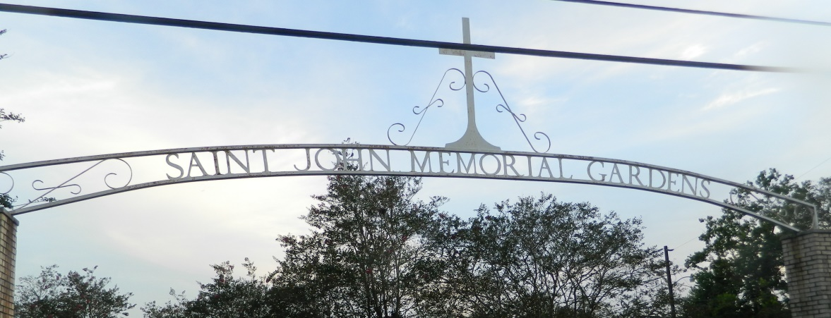

Richard "Bubba" Hardy Sr. at the age of 73 yrs. departed this earthly life and entered into eternal rest on Monday, July 9, 2018 at Ochsner Hospital of LaPlace, La. Beloved son of Mildred Narcisse and the late Bill Banks. Husband of the late Rose Mary Hardy. Loving Father of Richard "Manny" Hardy Jr. of LaPlace, Theresa Ducre, and Deseree Jones. Grandfather of Jada, Jashane, Jaden and Javen Hardy and Alonzo Rios. Brother of Barbara Narcisse, Joyce Ann Henderson, Joanna Kirklin, Gloria Mae Chatman, Emma Jean Baloney, Clarence, Ronald, and Alton Narcisse, and Eugene Banks. A host of nieces, nephews other relatives and friends. He was preceded in death by His Wife Rose Mary Hardy; His Father: Bill Banks; Sisters: Pamela Sanders and Mardell Anderson; His Brothers: William and Walter Chapman.

Pastors, Officers and Members of Providence II Baptist Church of Montz, La. and all neighboring churches are invited to attend the home going celebration on Friday July 13, 2018 at 10:00am at the Providence II Baptist Church 152 Union Lane Montz, La. Pastor Donald Brown Sr. officiating. Interment in St. John Memorial Cemetery of LaPlace, La. Visitation at the above name church from 8:00am until service time. Bardell's Mortuary of Mt. Airy, La. in charge. Information: 985-535-6837

Published in TheNewOrleansAdvocate.com from July 11 to July 14, 2018