Thelma Jean (King) Harrier
About 1931 – October 6, 1999

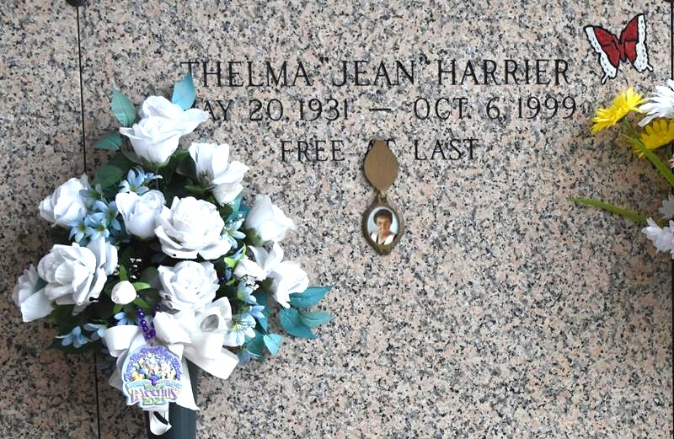

LAPLACE - Thelma "Jean" Harrier, 68, a native of Bonny Blue, Va., and a resident of Gramercy for 15 years, died Oct. 6. She was the wife of William Harrier and mother of Danny Knig, Peter Ziegler, Kathy Smith and Dani Jo Harrier. She was also the daughter of Nelson King and the late Mattie Mae King, and sister of Frankie Carter, Honey Young, Billie "Bug" Reese and Angel Cottrell. She is also survived by two grandchildren. She is predeceased by one grandchild.

Services were held Oct. 8 in the chapel of Millet-Guidry Funeral Home, LaPlace, with interment at St. John Memorial Gardens, LaPlace.
L'Observateur, LaPlace, LA
October 11, 1999

