Wayne A. Harrilal Jr.
December 18, 1987 – February 11, 2023

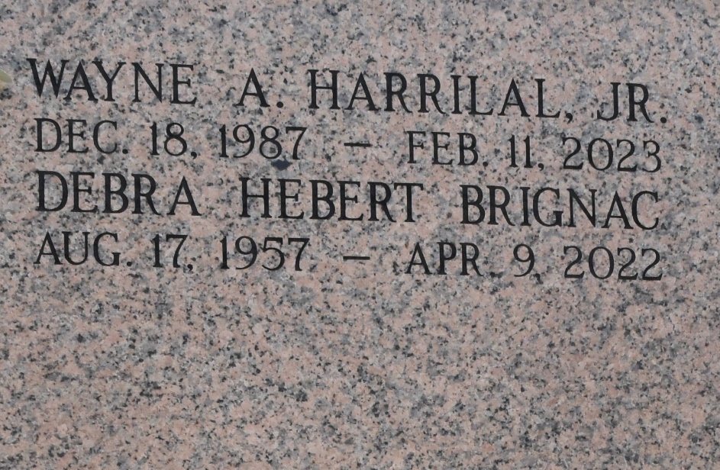

Wayne Harrilal, Jr. a resident of LaPlace passed away on Saturday, February 11, 2023 at the age of 35.
Father of Jada Harrilal, Dominic Harrilal, Sophia Harrilal, Jace Garrett, Destiny Harrilal, and Katelyn Ory. Son of Gail Hebert (Frank Walker, Jr.) and Wayne Harrilal, Sr (Jeannine Gentile). Brother of Glenda Pavageau (Luke), Ashley Harrilal (Stephen), Sharie Santiago, and Jema Harrilal. Uncle to eight nephews and nieces, and cousin to many.
Wayne was a family man. He loved and adored everyone in his family, especially his children. He also was known for driving his sisters crazy on occasion. He made sure to do life his way. However, his main hobbies were racing and working on cars.
Relatives and friends are invited to the Visitation and Funeral Service on Friday, February 17, 2023 at Millet Guidry Funeral Home. Visitation from 9:00 a.m. till 11:00 a.m. Funeral Service to follow at 11:00 a.m. A private graveside service will be held.

Obituary published on Legacy.com by Millet-Guidry Funeral Home
Feb. 14, 2023

