Hemon Harris Jr.

November 23, 1947 – August 6, 2012

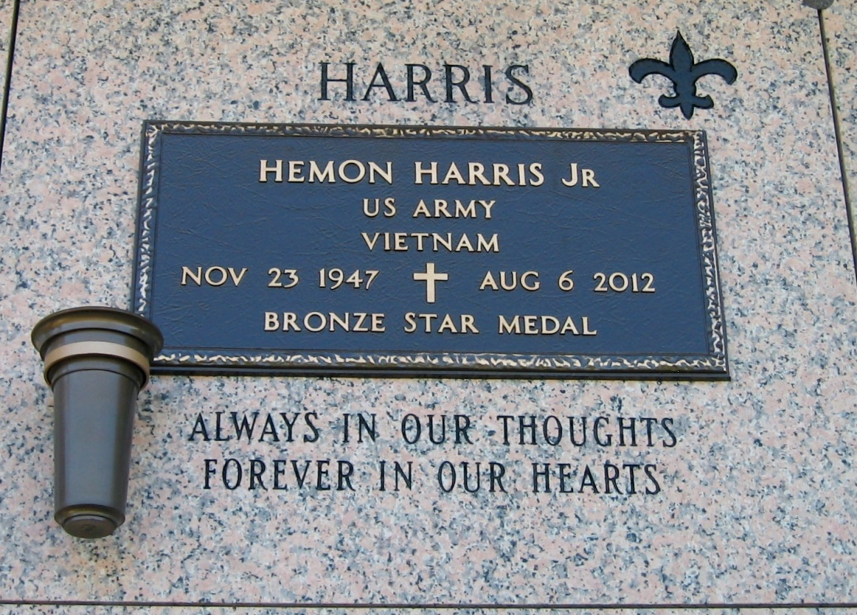

Photo by Bobby

Hemon Harris, Jr. entered into eternal rest on Monday, August 6, 2012 at Ochsner Medical Center. Beloved father of Todd D. Harris of Garland, TX and Tyra Harris-Upton (Dwayne) of Rowlett, TX. Son of the late Hemon Harris, Sr. and Evelyn Williams Harris. Brother of Cynthia Harris-Cook and brother-in-law of Fred Cook of Garyville, LA. Grandfather of D'Andre, Darius, and Skye. Uncle of Loukisha (Cleveland) Johnson. Also survived by aunts, uncles, cousins, and a host of other relatives.  
  
Relatives and friends, pastor and members of Mt. Zion #1 Baptist Church and other neighboring churches, and also employees of Dupont are invited to attend the Funeral Services at Mt. Zion #1 Baptist Church, 144 Little Hope St., Garyville, LA on Friday, August 10, 2012 at 11:00 a.m. Visitation will be on Thursday from 3:00 p.m. - 6:00 p.m. and on Friday at 9:00 a.m. until service time. Pastor Kevin Fredericks, officiating. Pastor Kent Fredericks (host Pastor). Interment St. John Memorial Gardens, 2205 W. Airline Hwy., LaPlace, LA.  
  
BARDELL'S MORTUARY of Mt. Airy, LA in charge. Information: (985) 535-6837.

**Times-Picayune, The (New Orleans, LA) - Thursday, August 9, 2012**

**Contributed by Jane Edson**