Reginald Hawkins Sr.
December 8, 1949 – February 7, 2021

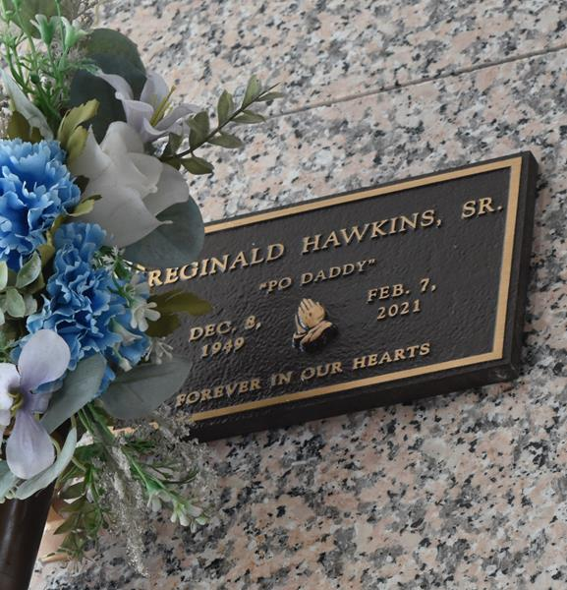

Reginald Hawkins, Sr. age 71 years, affectionately known as Po Daddy, peacefully entered into eternal rest at Waldon Health Care Center, Kenner, LA on Sunday February 7, 2021. Son of the late Stanley Welton Hawkins, Sr. and the late Ruby Lee Smith. Beloved father of Reginald Hawkins, Jr, Taraybia Hawkins-Nyamayaro (Givemore), Jarrett Hawkins (LaTonya), Reggie Williams and Regina Duncan (Kinyatto, Sr.). Brother of Bryan Eugene, Charles Eugene, Diane Hawkins, Patricia Hawkins, Sharon Eugene, Wanda Holloway, Vanessa Robertson (Kevin) and the late Stanley Welton Hawkins, Jr., Karen Washington and Debra Smith. Nephew of Gretchen Washington of Los Angeles, CA, Fran Bayas and Shirley Nedd of New Orleans, LA. Brother-in-law of Barbara Eugene Hawkins. Also survived by 11 grandchildren and a host of nieces, nephews, cousins, other relatives and friends.
The Family would like to express thanks to Walden Health Care, St. Joseph’s Hospice and Canon Hospice for the special care they provided.
Relatives and Friends of the Family are invited to attend a Public Walk Through on Saturday February 13, 2021 from 10:00 A.M. – 12:00 Noon at True Light Baptist Church, 258 S. Little Hope St., Garyville, LA 70051. Funeral Services for Family Members will begin at 12:00 Noon from True Light Baptist Church, 258 S. Little Hope St., Garyville, LA 70051. Interment will be Private. Final Arrangements are entrusted to Patrick H. Sanders Funeral Home & Funeral Directors, 605 Main St., LaPlace, LA 70068.

Tributearchive.com

