Sandra (Johnson) Hawkins
June 19, 1950 – October 20, 2017

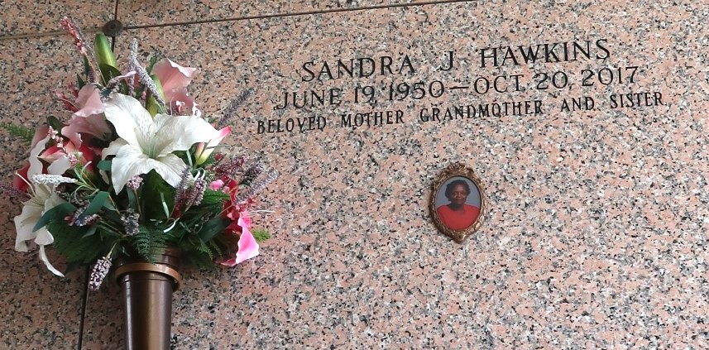

Sandra Johnson Hawkins (Age 67) on Friday, October 20, 2017 at Ochsner Medical Center, Jefferson, LA. A native and resident of Reserve, LA. Daughter of the late Edgar and Sedonia Weston Johnson. Mother of Reginald, Jr., Taraybia Hawkins-Nyamayaro (Givemore) and Jarrett Hawkins (LaTonya). Sister of Paulette Warner, Gretchen Phillip (Lugene), Dwight, Carl (Barbara) and Calvin Johnson, the late Edgar, Jr., Albert, Gary, Henry Carter and Darren Johnson and Stella Mae White. Also survived by 4 grandchildren and a host of nieces, nephews, cousins, other relatives and friends.
Relatives and friends of the family, also pastors, officers and members of New Rescue Mission Baptist Church and all neighboring churches are invited to attend the Funeral Service at New Rescue Mission Baptist Church, 361 E. 14th Street, Reserve, LA on Saturday, October 28, 2017 at 11:00 AM. Rev. Devin Mason, Pastor, Officiating. Interment St John Memorial Garden Cemetery, LaPlace, LA. Visitation at the above named church from 9:00 AM until Service. SERVICED BY ROBOTTOM

The Times-Picayune, New Orleans, Louisiana
Oct. 24 to Oct. 27, 2017

