Stanley W. Hawkins Jr.
1948 – January 4, 2020

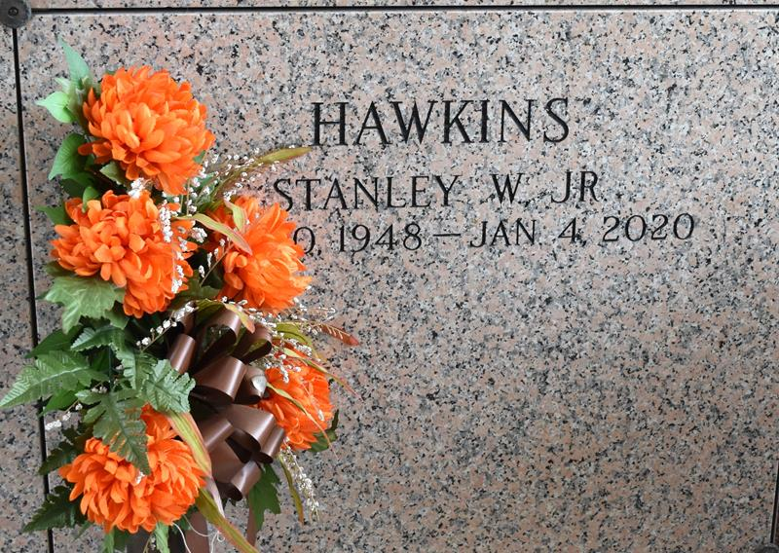

Stanley W. Hawkins Jr, age 71, entered peacefully into eternal rest on Saturday January 4, 2020 surrounded by loved ones. He was a native of St. John the Baptist Parish (Garyville). On December 30, 1948 Stanley W. Hawkins Jr. was born to the late Ruby Lee Smith and the late Stanley W. Hawkins Sr. He leaves his wife Barbara Eugene, son Bruce Pablo, 2 daughters Yolanda (Charles) Belvin and LoToya Lumar, 14 siblings, 9 grandchildren, 3 great grandchildren, 5 aunts, 4 uncles and a host of nieces, nephews, cousins and co-workers to cherish his memories.
Wake will be held on Friday, Jan. 10th from 6-8 pm and visitation will be held on Saturday, Jan. 11th from 9 am until service at 11 am at True Light Baptist Church, 258 S. Little Hope St., Garyville, LA 70051. Interment: St. John Memorial Gardens. Remains Entrusted To: Affordable Funeral Home.
The Times-Picayune, New Orleans, Louisiana
Jan. 9 to Jan. 11, 2020

