Kentrelle A. Hayes
December 13, 1988 – September 16, 2015

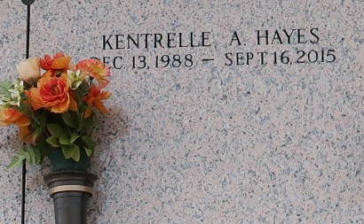

On September 16, 2015 Kentrelle A. Hayes, age 26, son of Nicole H. (Joseph) White departed this earth. He leaves behind, to cherish his memories, a brother, Trenton Hayes. Survived by a host of aunts, uncles, cousins, friends and other relatives
Funeral service on Saturday, September 26, 2015 at True Light B.C., 258S. Little Hope St, Garyville, LA 70051 at 11:00am. Internment St. John Memorial Gardens, LaPlace, LA. Service Entrusted to Hobson Brown Funeral Home Garyville, La 70051 985-535-2516

The Times-Picayune, New Orleans, Louisiana
Sep. 23 to Sep. 25, 2015

