Jessica Lynn Haywood
September 3, 1984 – April 5, 2018

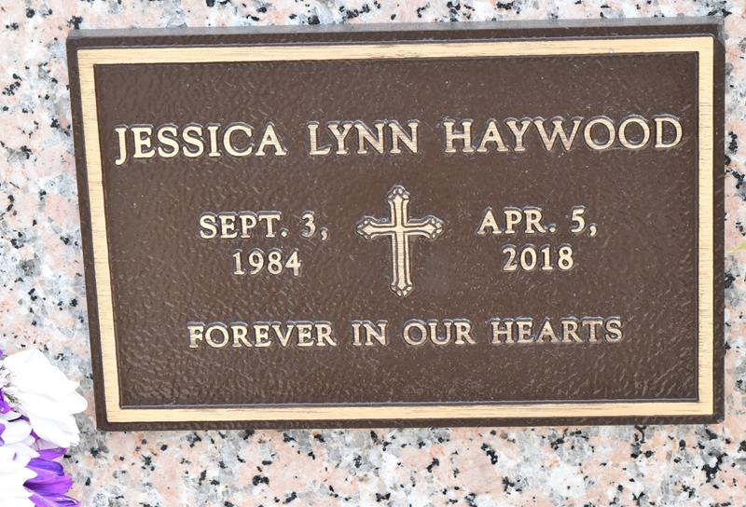

Jessica Lynn Haywood passed away on Thursday, April 5, 2018.
She was 33, a native of LaPlace, LA and a resident of Tickfaw, LA.
Beloved mother of Zachary Alexander Haywood and Allie Paige Haywood.
Daughter of Donald Haywood, Jr. and the late Danielle Winters Haywood.
Step-daughter of Pamela A. Haywood. Sister of Jennifer Haywood, Naomi Haywood, Michelle Vega and Kristy Vega.
Unknown source

