David Paul Hebert
August 28, 1970 – April 18, 2011

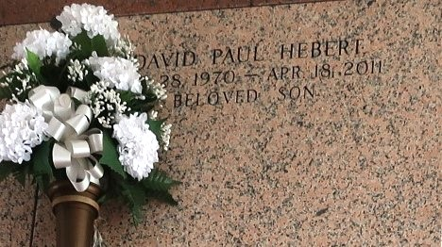

David Hebert passed away on Monday, April 18, 2011. Beloved son of Leonard and Mary Madere Hebert. Age 40 years. A native and resident of LaPlace.
Relatives and friends are invited to attend services. Visitation at Millet-Guidry Funeral Home, 2806 W. Airline Hwy., LaPlace, LA, on Monday, April 25, 2011 from 9:00 am until 12:00 Noon, followed by Religious Services at the Funeral Home Chapel at 12:00 Noon. Burial in St. John Memorial Gardens, LaPlace. In lieu of flowers, Masses are preferred.
New Orleans Times Picayune (LA)
April 24, 2011

