Judy Francis (Ferraro) Hebert
August 1, 1953 – February 18, 2022

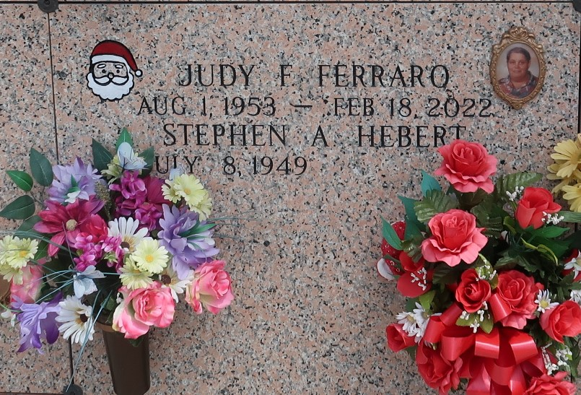

Judy Francis Ferraro-Hebert passed away peacefully on February 18, 2022, at the age of 68. She is preceded in death by her parents, Ignazio and Dorothy Ferraro, her mother-in-law Irene Hebert, her nephew Keith Ferraro, and other loving family members. She is survived by her husband Stephen Hebert, her son Oneil Oubre (Missy), her grandchildren, Brooke Trahan, Tylor Oubre (Leila), Austin Roussel, and Haiden Oubre, her siblings, Verna Cambre (Paul), Gail Roussel (late Mark), Bonnie Comardelle (Luther), Maryann Champagne (Boobie), Virginia Zeringue (Kirk), Nicky Ferraro (Libby), Anna Ferraro (Deke), and Laura Hebert (Jim), and countless nieces, nephews, family and friends, and her best friend Sharleen Jouty.
She was the most kindhearted person in the world and devoted her life to helping any and everyone that she came in contact with. She loved spending time with her family and friends, running the roads, and Bingo. Judy's favorite holiday was Christmas. She loved decorating and being with family during the Christmas holiday.
Relatives and friends are invited to attend the Visitation at Rose Lynn Funeral Home, 1870 Cabanose Ave., Lutcher on Tuesday, February 22, 2022 from 6:00 p.m. to 9:00 p.m. and on Wednesday, February 23, 2022 from 9:00 a.m. to 11:00 a.m. The Funeral Mass will follow at St. Joan of Arc Catholic Church, 529 W. 5th St., LaPlace at 12:00 p.m. Interment in St. John Memorial Gardens Cemetery, LaPlace, LA. To view or sign the online guestbook, please visit www.roselynnfuneralhome.com.

The Times-Picayune, New Orleans, Louisiana
Feb. 21 to Feb. 23, 2022

