Leonard James Hebert
March 9, 1991 – July 30, 2019

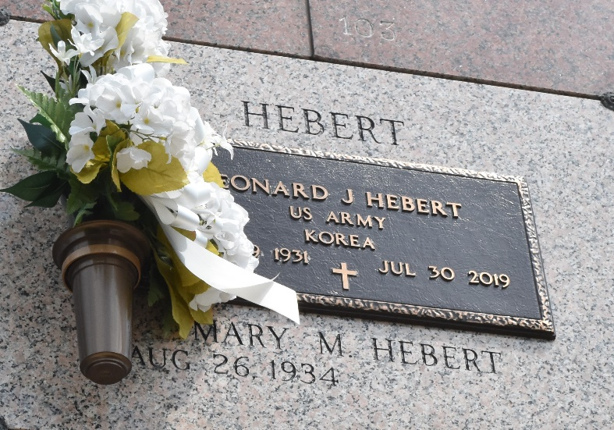

Leonard James Hebert ‘Pokey’ passed away on Tuesday, July 30, 2019 at the age of 88. He was a born in Norco, LA and was a resident of LaPlace, LA. Beloved husband of Mary Madere Hebert. Father of the late David Paul Hebert. Son of the late Carrie Falterman Hebert and Ray Paul Hebert. Brother of the late Rev. Msgr. Ray Paul Hebert (St. Edward the Confessor, Metairie and Immaculate Conception, Marrero). Also survived by nieces and nephews.
Leonard proudly served our country in the U.S. Army during the Korean War. He was a member of the Knights of Columbus Council 5935, VFW Post 3337 and American Legion Post 383 and enjoyed bowling.
Relatives and friends are invited to attend the Funeral Mass at St. Joan of Arc Catholic Church, 529 W. 5th Street, LaPlace, LA on Saturday, August 3, 2019 at 1:00 p.m. Visitation at the church from 11:00 a.m. until 1:00 p.m. Interment in St. John Memorial Gardens Cemetery.
In lieu of flowers, Masses preferred.
Millet-Guidry Funeral Home, LaPlace, LA
August 2, 2019

