Virginia (Hernandez) Hebert
November 22, 1959 – July 1, 2020

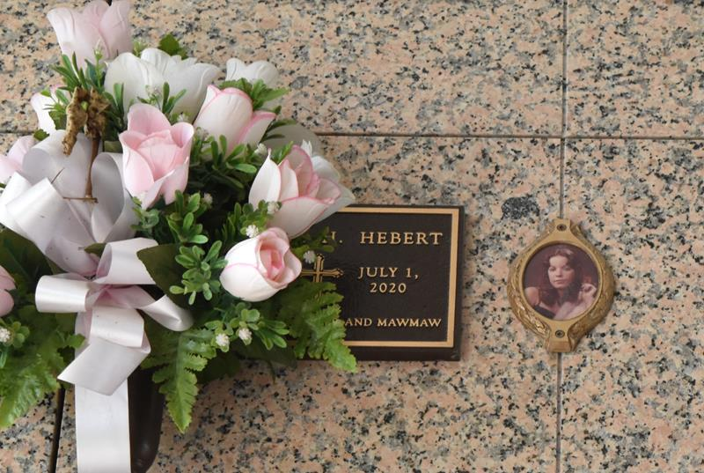

Virginia Hernandez Hebert passed away on Wednesday, July 1, 2020 at the age of 60. She was a native of Jersey City, NJ and a resident of LaPlace, LA. Beloved wife of Stephen Scott Hebert. Loving mother of and Shawn Stephen Hebert (Kelliann) and the late Dale Michael Hamlin. Grandmother of Dakotah Hamlin, Drake Hamilin and Logan Patterson. Daughter of the late Fe Nieto and Sergio Hernandez. Sister of Sergio ‘Danny’ Hernandez, Miriam Arelis Hernandez and Doris Hernandez. Niece of Pedro and Coralia Francisco. Also survived by other nieces and nephews.
Relatives and friends are invited to attend a Graveside Service at St. John Memorial Gardens Cemetery, LaPlace, LA on Thursday, July 9, 2020 at 10:00 a.m. Arrangements by Millet-Guidry Funeral Home. To share memories or condolences, please visit www.milletguidry.com

Millet- Guidry Funeral Home, LaPlace, Louisiana

