Shirley A. (Sears) Heier
December 29, 1924 – November 17, 2008

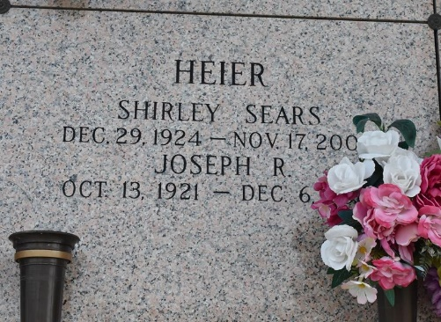

Shirley A. Sears Heier on Monday November 17, 2008 at 9:00am. Beloved wife of Joseph R. Heier. Mother of Joseph E. Heier and Kathleen S. Hinton. Grandmother of Aimee Hinton Edmonds, Sheri Heier Courtney, Kyle Heier and Shannon Hinton. Great-Grandmother of Brooke and Brennan Edmonds and Kellen Heier. Also survived by numerous friends. Age 83 years. A native of Kansas City and a resident of LaPlace for the past 18 years.
Relatives and friends are invited to attend services. Visitation at Millet-Guidry Funeral Home, 2806 W. Airline Hwy, LaPlace, La., on Wednesday, November 19, 2008 from 11:00am to 1:00pm. Followed by Religious Services at the Funeral Home Chapel at 1:00pm. Burial in St. John Memorial Gardens Cemetery LaPlace. In lieu of flowers, donations preferred to a charity of your choice.

The Times-Picayune, New Orleans
November 18, 2008

