Dana Lea Hicks

July 1, 1969 – March 11, 2008

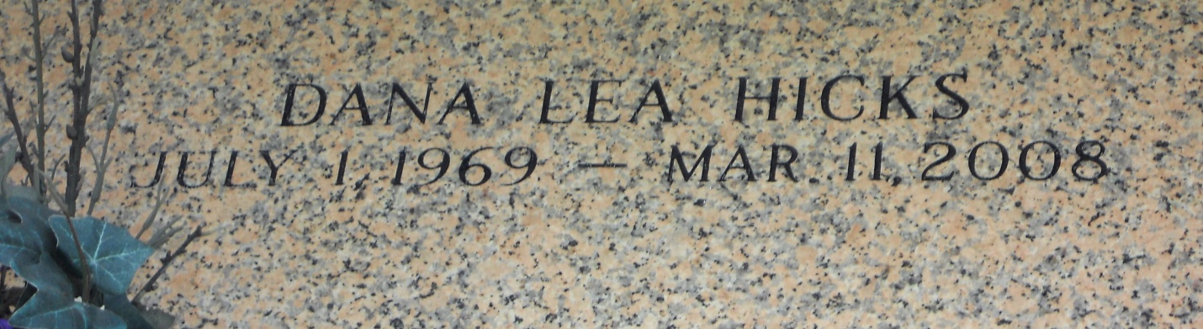

Photo by Team T Lo

Dana Lea Hicks went to be with Jesus on Tuesday, March 11, 2008 at 6:00 p.m. Beloved mother of Michael and Haley Hicks. Daughter of Danny and Arlene Hicks. Sister of Tamara Hicks White and half-sister of Christopher Hicks. Lifelong companion of Michael Carson. Age 38 years, a native of Kenner and resident of LaPlace for the past 30 years.  
  
Visitation at Millet-Guidry Funeral Home, 2806 W. Airline Hwy., LaPlace, LA, on Friday, March 14, 2008 from 5 p.m. to 9 p.m. and on Saturday from 8 a.m. to 9:30 a.m. Followed by Religious Services at the Lutheran Church of the Galilean, 3404 Hwy 51, LaPlace, at 10 a.m. Burial in St. John Memorial Gardens, LaPlace, LA.  
  
In lieu of flowers, please donate to your favorite charity.

**Times-Picayune, The (New Orleans, LA) - Thursday, March 13, 2008**

**Contributed by Jane Edson**