Charles Thomas Hills Sr.

December 30, 1926 – October 21, 2013

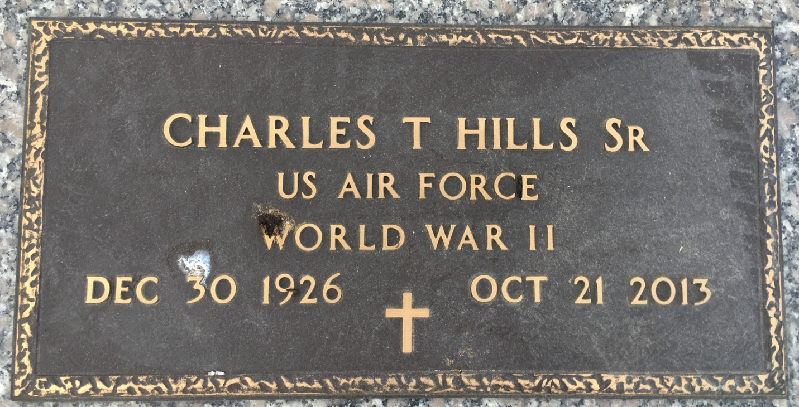

Photo by Team T Lo

CHARLES THOMAS HILLS, SR. on Monday, October 21, 2013 at his home in LaPlace, LA.  
  
Son of the late Lilly Patterson and James T. Hills. Father of Charles T. Hills, Jr. Also survived by a devoted friend, Michael Travis (Pamela). Age 86 years. A native of New Orleans, LA and resident of LaPlace, LA.  
  
Relatives and friends of the family are invited to attend the Funeral Service at Robottom Mortuary, 850 Hwy 44, Reserve, LA, on Monday, October 28, 2013 at 11:00 AM. Interment St John Memorial Garden Cemetery, LaPlace, LA. Visitation at the above named funeral home from 10:00 AM until Service time.  
  
SERVICED BY ROBOTTOM

Times-Picayune, The (New Orleans, LA) - Friday, October 25, 2013

Contributed by Jane Edson