Barry D. Holland

May 26, 1947 – Aug 19, 2005

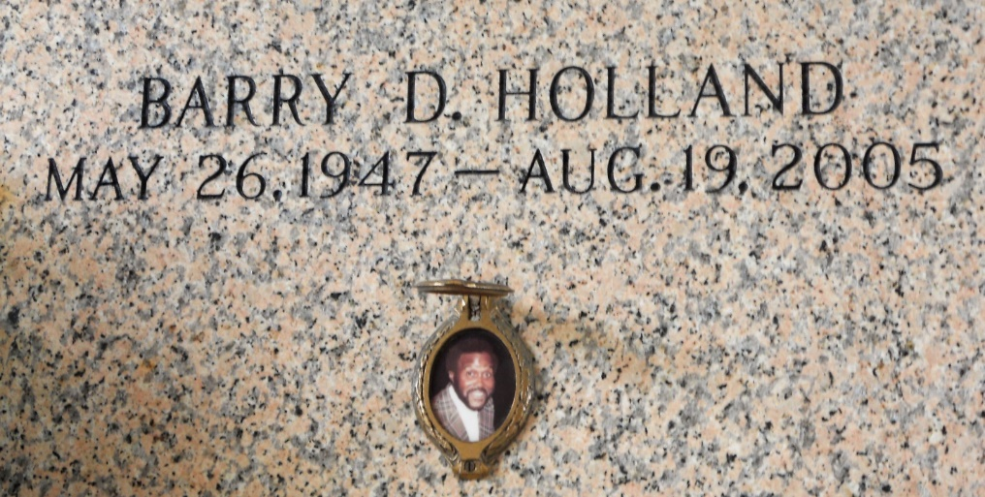

Photo by Team T Lo

Barry Holland, A Retired Bus Driver, On Friday, August 19, 2005 At River Parishes Hospital, Laplace, La. Age 58 Years. A Native Of New Orleans, La And A Resident Of Laplace, La.

Survivors Include 1 Daughter: Yolanda Miles; 5 Sons: Barry Howard, Derrick And Jeremy Holland, Corey Williams, And Kendall Coleman; 3 Brothers: Michael, Ronald And Allan Holland; 1 Sister: Cheryl Holland; And 9 Grandchildren.

Funeral Services Will Be Held On Thursday, August 25, 2005 At 1:00 Pm At First Assembly Of God, 3001 Hwy 51, Laplace, La. Burial At St. John Memorial Gardens, 2205 W. Airline Hwy., Laplace, La. Visitation Will Be On Wednesday, August 24, 2005 At 5:30 Pm Until 7:30 Pm At Hobson Brown Funeral Home, 134 Daisy St. And Thursday At The Church 12:00 Noon. Hobson Brown Funeral Home In Charge.

Times Picayune, New Orleans, Louisiana

August 24, 2005