Ronald Holland
June 30, 1953 – December 15, 2018

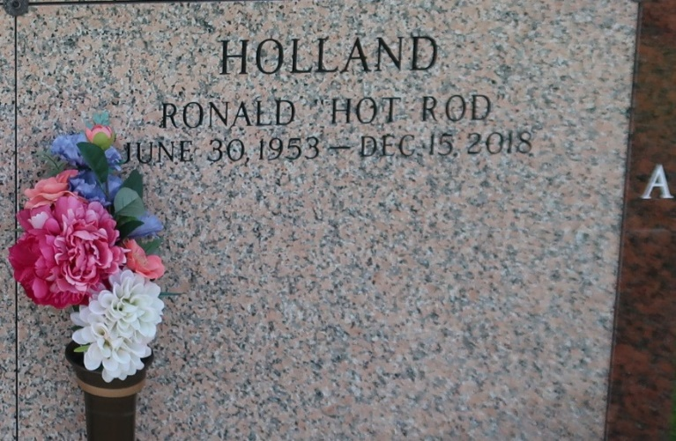

Ronald Holland, a retired electrician and lifelong resident of Laplace, LA, died on December 15, 2018 at the age of 65. Ronnie, affectionately known as "Hot Rod" was born on June 30, 1953 to the late Theresa Holland Butler and Harvia Johnson. He was also reared by his loving stepfather, the late Junius Butler. Ronnie was the fourth brother of Cheryl Gordon, Harvia and Craig Johnson, Jacqueline Williams (Mat) and the late Michael, Barry, Allen, Patricia and Cheryl Lee Holland, and Shirley Johnson.
He was a parishioner of St. Joan of Arc Catholic Church in Laplace, LA. He was educated in the St. John Parish School System and also attended Delgado Community College. He retired from Northside Electric after 40 years of service. Ronnie had an obsession for drag racing. He loved driving and bragging about his 1973 Plymouth Duster. He loved music and played the bass guitar; a talent he inherited from his grandfather, the late Mitchell Lennix Sr. (Sip). Ronnie was one of the greatest fans the Pittsburgh Steelers will ever have. Ronnie was associated with the Krewe of Agape Social Club and reigned as King Agape XIV, the thrill of his life, because he considered himself the KING.
Cherishing his memories are his wife, Sharon Watkins Holland, his three sons, Ronald Jr., Eric (Kia) and LaBaren; and a devoted nephew Henry Holland. Ronnie also leaves his mother-in-law, Ulia Watkins; sisters-in-law, Trudy Thomas (Lionel); Renee Frye (Johnnell); Carmen Holland; and brother-in-law, Sherman Watkins (Ivory) and special uncle, Andrew Favors (Therese). His three devoted aunts, Delores, Myrtle and Barbara Lennix -- "My Nephew." He also leaves six grandchildren, two great-grandchildren and a host of nieces, nephews, cousins other relatives and friends. He was preceded in death by his parents, three brothers, three sisters, and a father-in-law, Roosevelt Watkins. May the souls of those dearly departed family members rest in peace.
A mass of Christian burial will be held on Saturday, December 22, 2018 from St. Joan of Arc Catholic Church, 529 W. 5th St., Laplace, LA 70068, for 11:00AM. Visitation from 9:00AM until service time. Rev. Patrick Collum, Celebrant. Entombment St. John Memorial Gardens, 2205 W. Airline Hwy., Laplace, LA. Treasures of Life Funeral Services entrusted with his final care. 315 E. Airline Hwy, Gramercy, LA 70052.

The New Orleans Advocate, Louisiana
Dec. 19 to Dec. 22, 2018

