Norma Jean (Buckley) Hoover
June 5, 1932 – March 20, 2010

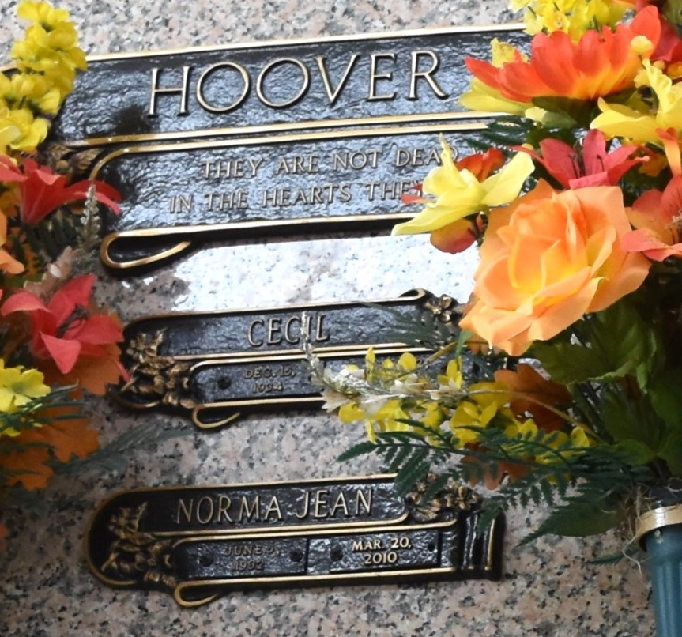

Norma Buckley Hoover passed away on Saturday, March 20, 2010. Beloved wife of the late Cecil Hoover. Mother of Tony Hoover, Chris Hoover and wife Nancy and Jodie Mapes and husband Tommy. Grandmother of Jeremy Hoover, Kristi Cooper, Brantley and Britton Mapes and the late Brandon Hoover. Great-grandmother of Carley, Jace, and Kaydence Hoover and Gabriel Cooper. Age 77. A native of Mississippi and a resident of LaPlace.
Relatives and friends are invited to attend services. Visitation at Millet-Guidry Funeral Home, 2806 W. Airline Hwy., LaPlace, La., on Tuesday March 23, 2010 from 9:00 am to 11:00 am. Followed by Religious Services in the funeral home Chapel at 11:00 am. Burial in St. John Memorial Gardens Cemetery LaPlace, La.

The Times-Picayune, New Orleans, Louisiana
March 23, 2010

