Henry J. Hotard Jr.
February 16, 1939 – February 3, 2012

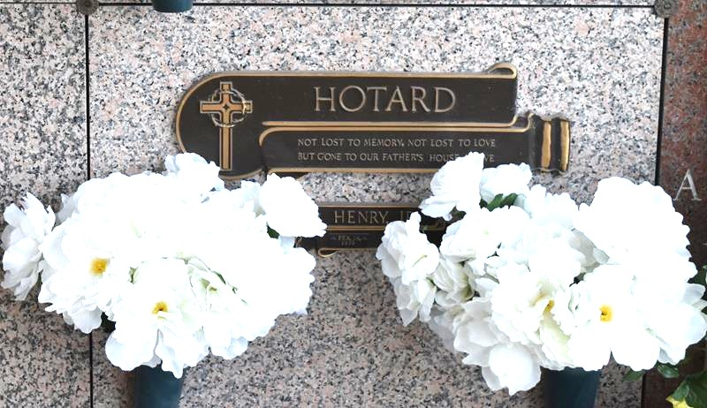

Henry J. Hotard, Jr. passed away peacefully on Friday, February 3, 2012, at the age of 72. He was born on February 16, 1939, in New Orleans, LA and was a resident of LaPlace, LA for all of his adult life. Henry was the beloved husband of Sandra Akin Hotard. He was the loving father of two daughters: Michelle Hotard of LaPlace and Jeanette "Gigi" H. Prisco (Randy) also of LaPlace. He is survived by two grandchildren: Amanda Arcuri and Allison Arcuri. Henry had two stepsons: Dane Haydel and Mathew Haydel (Keri). He also had three stepchildren: Adam, Jessica and Kayla Haydel. He had one sister Joyce H. Harvey (Jack) of LaPlace. Henry was preceded in death by his parents, Henry J. Hotard Sr. and Elodie Y. Hotard of LaPlace.
In 1966 he was employed by the St. John the Baptist Parish Assessor's office, where he worked as Chief Deputy Assessor. In 1974 he was elected as the St. John the Baptist Parish Assessor which office he held for 28 years. Previous to his retirement he also served as Secretary, Treasurer and later President of the LA Assessors Association. He will be deeply missed by his relatives and many friends who always enjoyed his good nature and humor.
Family and friends are invited to attend services. Visitation at Millet-Guidry Funeral Home, 2806 W. Airline Hwy., LaPlace, LA on Tuesday, February 7, 2012 from 8:00 am to 9:45 am, followed by Religious Services in the Funeral Home Chapel at 10:00 am. Burial in St. John Memorial Gardens, LaPlace, LA.

The Times-Picayune, New Orleans, Louisiana
February 4 to February 5, 2012

