Darlene B. (Seddelmeyer) Hudson
January 10, 1951 – February 10, 2015

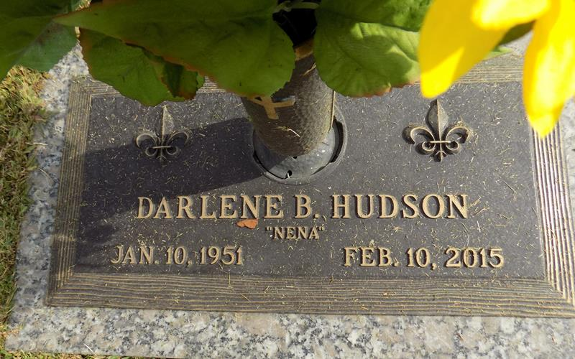

Darlene Ann Seddelmeyer Brady Hudson, age 64, passed away on Tuesday, February, 10, 2015. Darlene was the devoted wife of Reggie Hudson and the late Michael F. Brady. She was loving mother of Tia Brady and Tiffany B. Smith (Chris) and stepmother of Noel Hudson (Kelly), proud grandmother of Mikayla, Isabella Rose, and Brandon Smith, Katie Beth, Wil, and Klaire Hudson. She was the daughter of the late Henry and Esther Seddelmeyer. Darlene is survived by her twin brother David Seddelmeyer (Debbie) and sisters Barbara Johnson (Dan) and Carol Stiles (Bill). She leaves behind numerous nieces, nephews, other relatives and friends to cherish her memory.
Darlene was a former teacher at Atonement Lutheran School. She was a member of the church's choir, Prayer Shawl Ministry, Board of Christian Education, and Board of Christian Concerns. Her faith was evident to all who knew her.
Relatives and friends of the family are invited to attend the Celebration of life at Memorial Baptist Church, 5701 Veterans Blvd., Metairie, on Saturday, February 14, 2015 at 11:15am. A visitation will take place at Leitz-Eagan Funeral Home, 4747 Veterans Blvd., Metairie, from 9:00 am until 11:00 a.m.-interment in Laplace at St. John Memorial Gardens. In lieu of flowers, donations may be made to the Michael F. Brady Scholarship Fund at Atonement Lutheran Church, 6500 Riverside Dr., Metairie, 504-887-0225, preferred. Condolences may be offered at www.leitzeaganfuneralhome.com.
The New Orleans Advocate (LA)
Feb. 11 to Feb. 14, 2015.

